KITTENS

ARTIST/ INSTRUCTOR: GLENICE MOORE

SURFACE: I used a 16 x 20 Watercolor canvas; I like these because they are very easy to paint on and are very smooth. They also accept Oil paint and watercolor as well as Acrylic paint.

PALETTE: DECO ART TRADITIONS:
Carbon black
Aquamarine
Light Grey
Opaque White
Burnt Umber
Burnt Sienna
Perinone Orange
Vermillion
Quinacradone Gold
Raw Sienna
Dairylide Yellow
Yellow Deep

AMERICANA BLACK AND A SPONGE ROLLER TO PRIME SURFACE

BRUSHES: DYNASTY BLACK GOLD SERIES 206
3/4 OR 1 INCH Flat Wash Brush
#’s 12, 8 and 4 Shader Brushes
#’s 12, 8 and 4 Wave Brushes
# 4 or 6 Round Brush
Glenice Shadow Dancer (Double Ended Blender)

MISCELLANEOUS SUPPLIES:

Viva Paper Towels or Blue Shop Towels (These are important as they remove all excess water from your brushes so that you do not dilute the paint to much. Other brands leave to much water in the brush and your colors will be runny.

Easel (Optional)
Sta-Wet Palette system
Black and White Charcoal Pencils for making corrections on your surface.
White Graphite paper and a pencil or stylus
Water Container
Table Cover
Sponge Roller for applying Black Americana Primer to surface.

GETTING STARTED: Prime your surface with the Sponge Roller and Americana Black. Work the paint into the tooth of the surface and make sure you have a smooth even coverage.
Let Dry.

When Dry you can apply your pattern with the White Graphite Paper. You may wish to fasten the pattern to the surface with a little Masking Tape.

WE WILL BE BLOCKING IN VALUES. This is what I call base coating. It is applied thin applications of color to the subject. This established the shapes and the values. I use a lot of dry brush in this step so as not to get to much paint, if you apply heavy coats of paint it will make the project much harder,

BACKGROUND:
Use the large Flat Wash brush and apply an even coat of Traditions Carbon Black to the sides and across the top of your surface. While still wet work in a mix of Carbon Black + Aquamarine around the kittens and blend into the straight black. Use an X stroke. As a little pure Aquamarine above the kitten’s heads with a lightly loaded brush. It is ok to leave some texture in your strokes. Let dry.

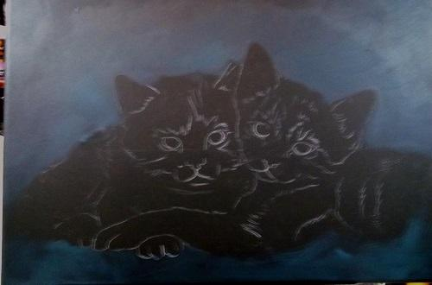

KITTEN #1 (ON THE LEFT):
Mix Light Grey + a small amount of Carbon Black and a little Aquamarine to make a soft dark grey color. Lightly load the tips of the #12 Wave and add the dark on the hind leg. Lightly flip some hair strokes into the background. Use a very light touch for this. Add the white area with Opaque White and again use the same brush and technique. Add some shading with the dark mix.

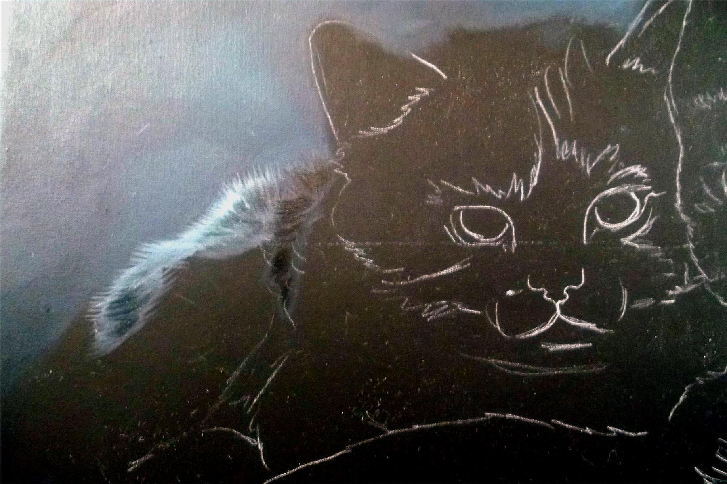

The next step is to block in the side of the face and the paw and around the edge of the ear with Opaque White + a tiny touch of the Aqua color. This important thing here is to use the Wave (#8) to lightly flip in hair strokes where one color touches another or where it touches the background. Use the chisel edge to add the white around the ears. Remember that this is only blocking in. No Detail at this time.

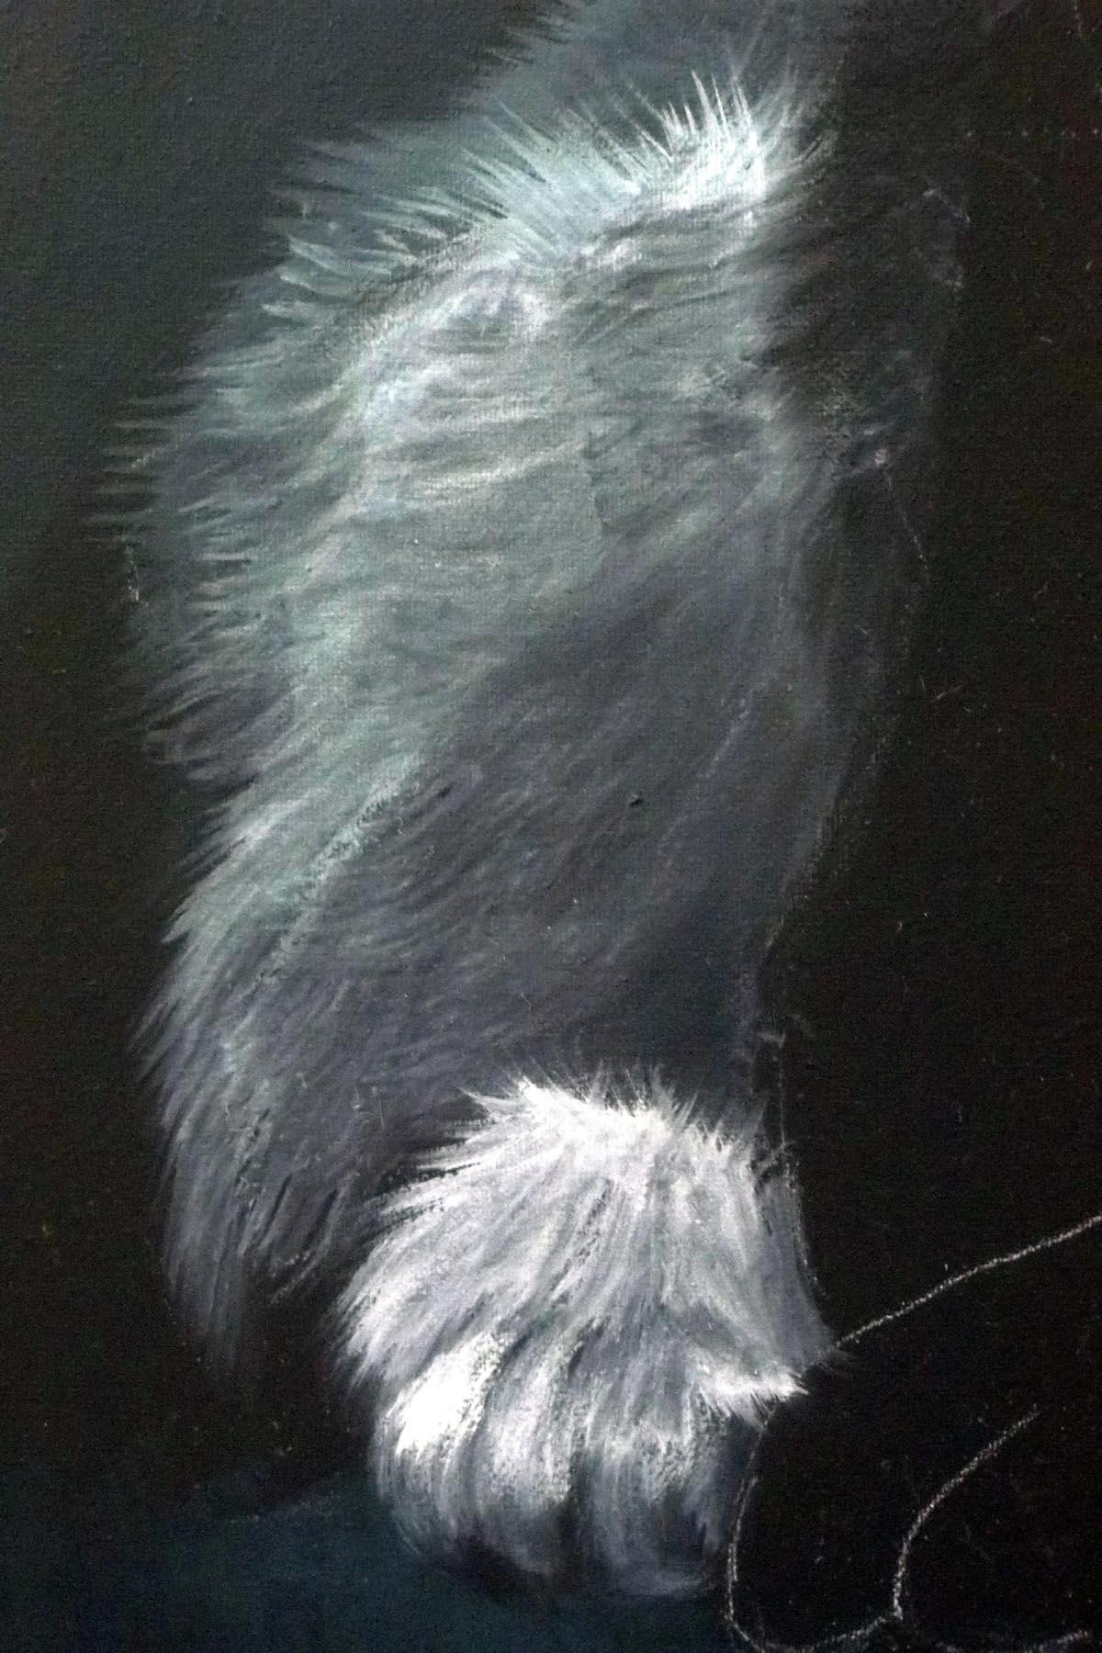

Block in the chest area with white + touch of Aqua and the #12 Shader. Go back and add more white to the mix and begin brightening all of the highlighted areas. Pay close attention to the hairs direction and the hair length, You should pull your strokes in the direction that the hair grows.

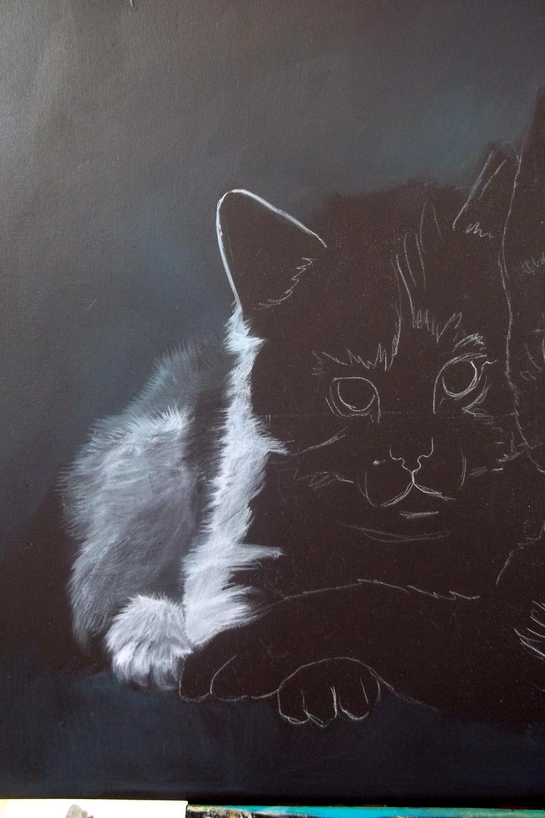

Make a medium dark mix with Light Grey + touch of Black = a touch of Aqua and add all the darker markings on the face. Add more Light Grey to mix to lighten it and add the lighter area across the top of the head and around the ears. Use the #8 Wave. Keep your strokes loose and relaxed. Do not over work or over blend.

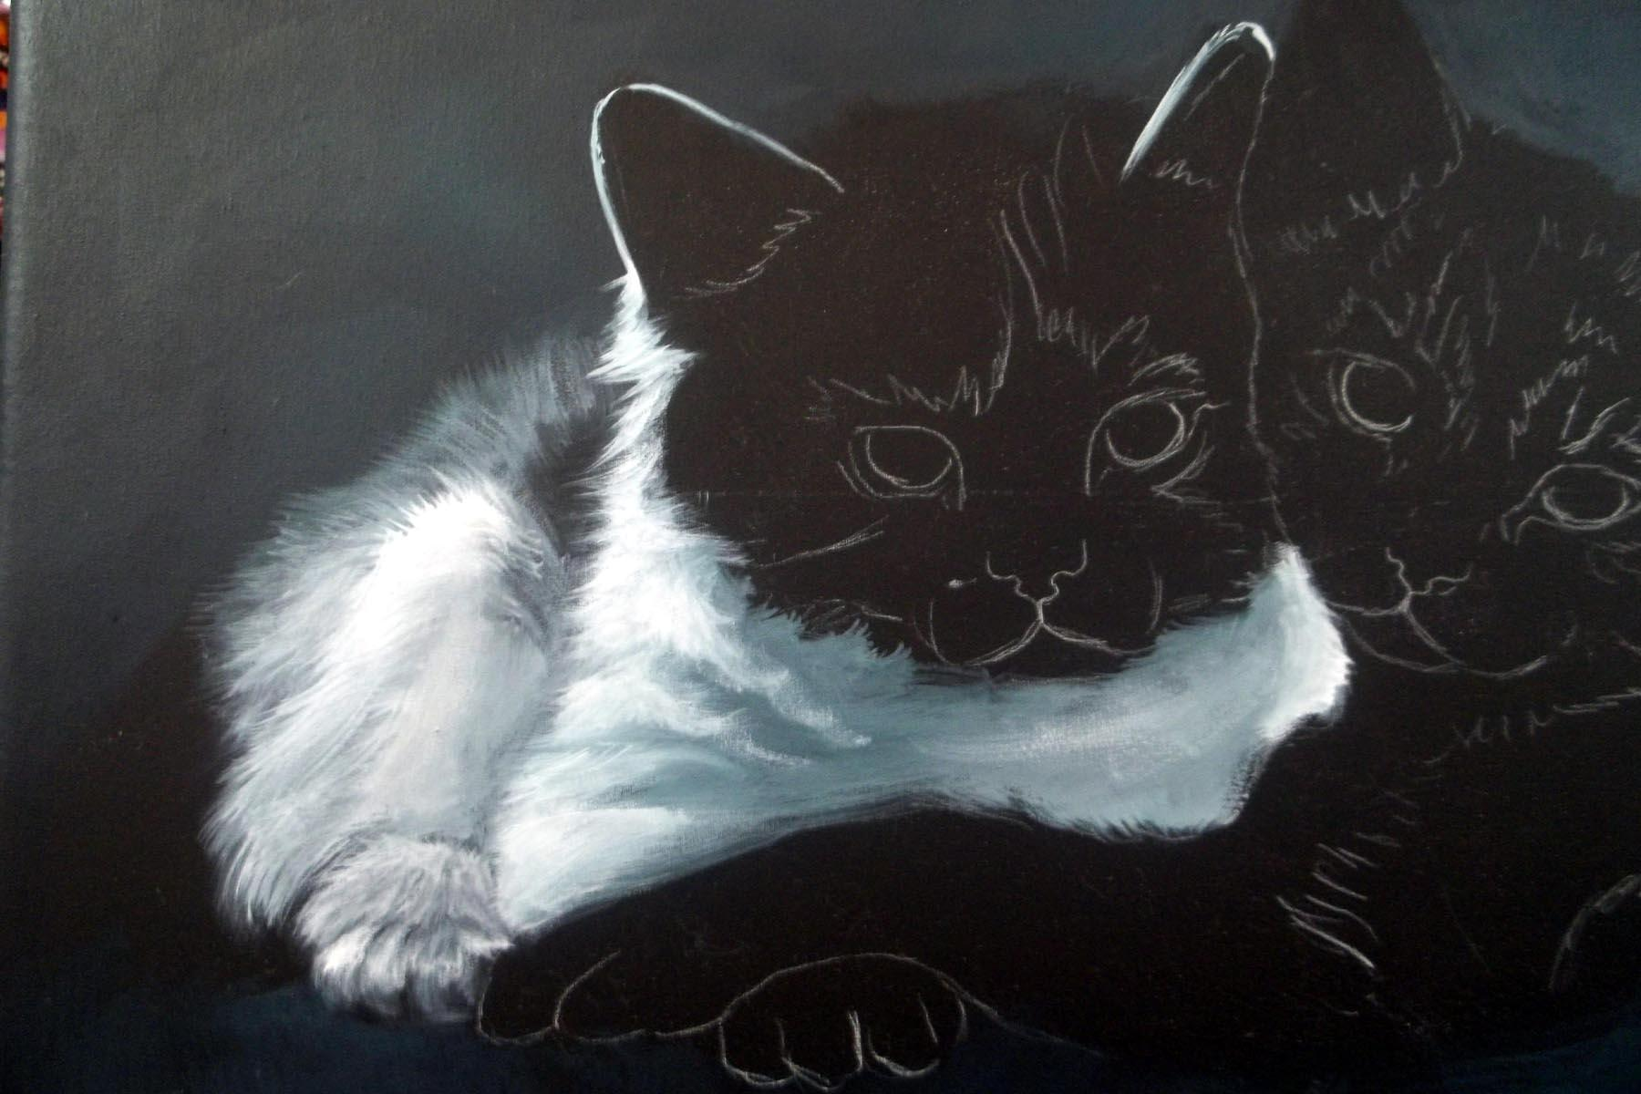

Use the darker mix from above and add a little Black to it and add the dark on the forehead and the cheeks. Refer to you reference often!

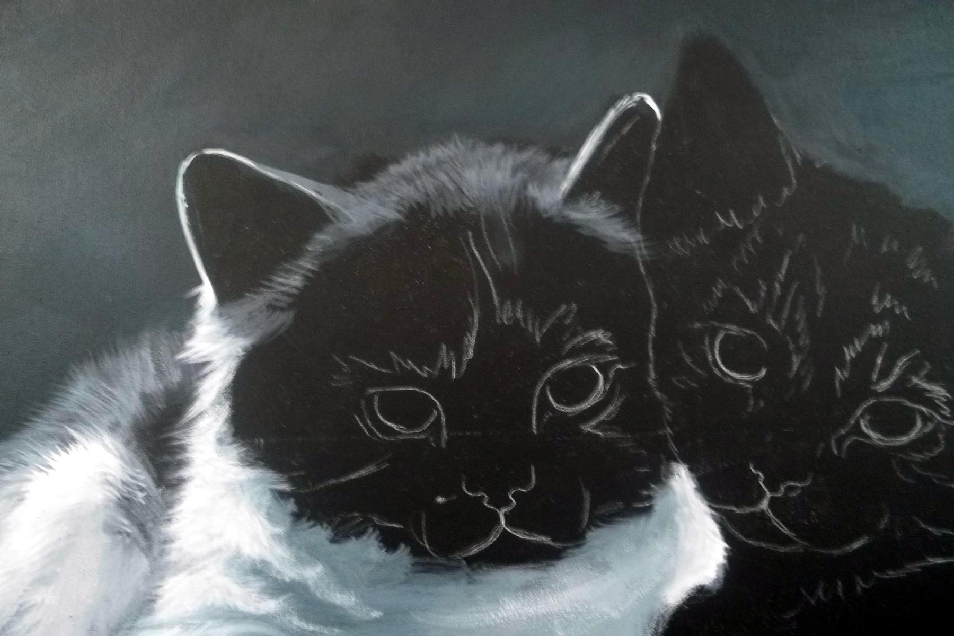
Add the white areas on the face with a mix of Light Grey + White and a tiny touch of Aqua. Use the #8 Wave to add hair strokes where on color touches another.

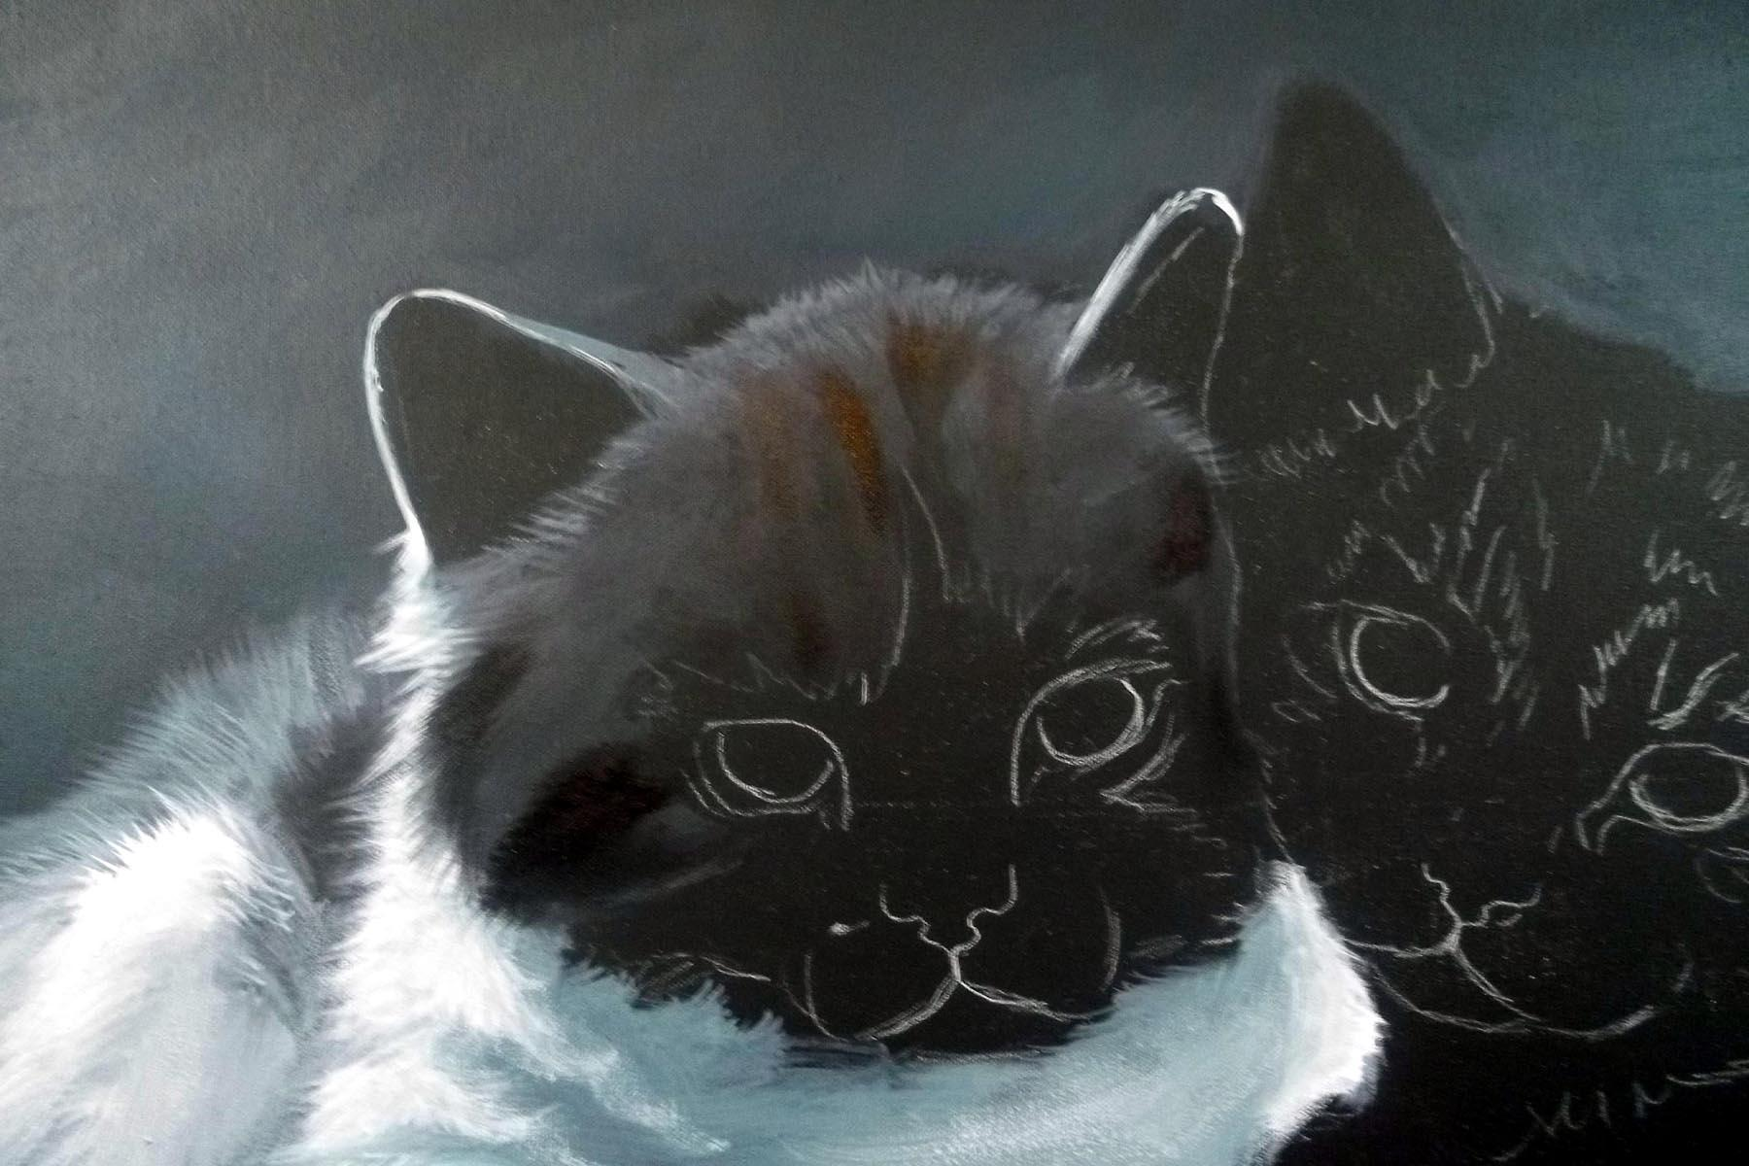

Mix a small amount of Burnt Sienna and White to make a soft pinkish color. Use this for the inside of the ears and on the nose and around the mouth. Soften the edges with the Shadow Dancer. Add a little of the Dark Grey mix to this to add shading.
Use the round brush and Black to carefully outline the eyes. When this is dry use the small shader and Aqua + a touch of the dark mix to base in the irises.
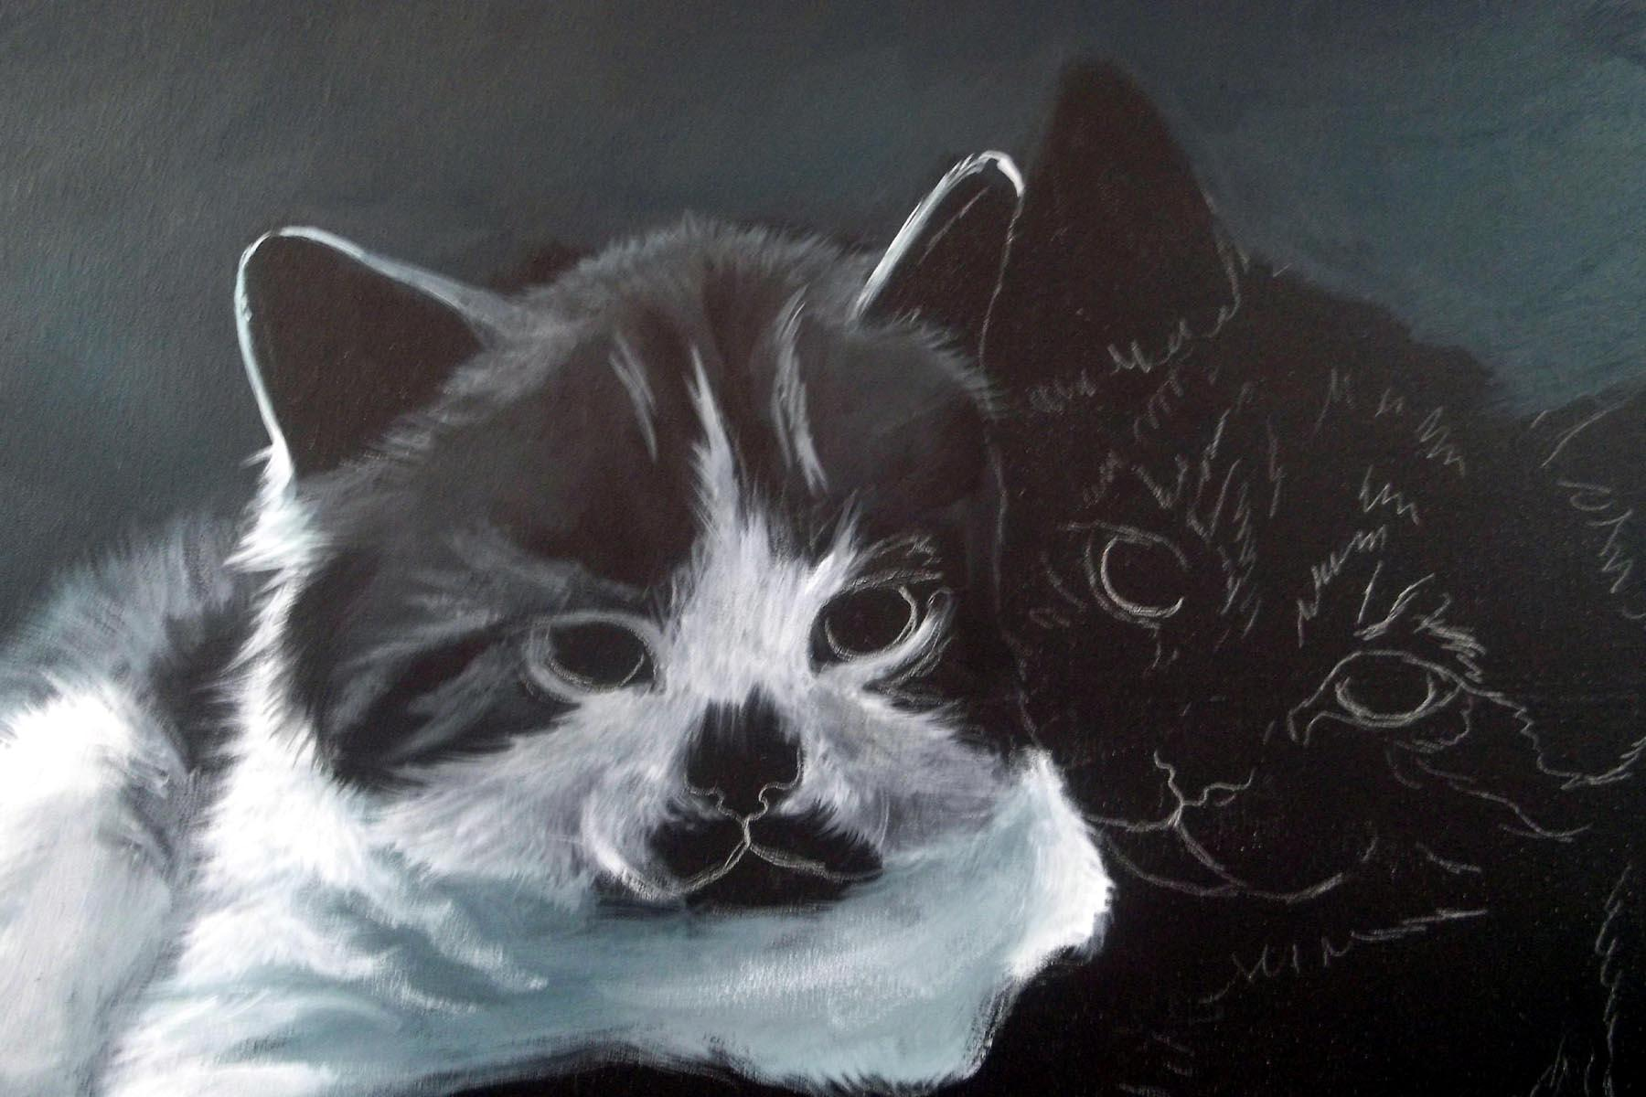
Mix up a rust color with Burnt Sienna + Perinone Orange + Quinacradone Gold and a little Medium White. You can adjust this color by adding more Medium White to suit your taste, Add the Orange fur to the face of Kitten #1. Use the #8 Wave to lightly flip in the hair strokes,

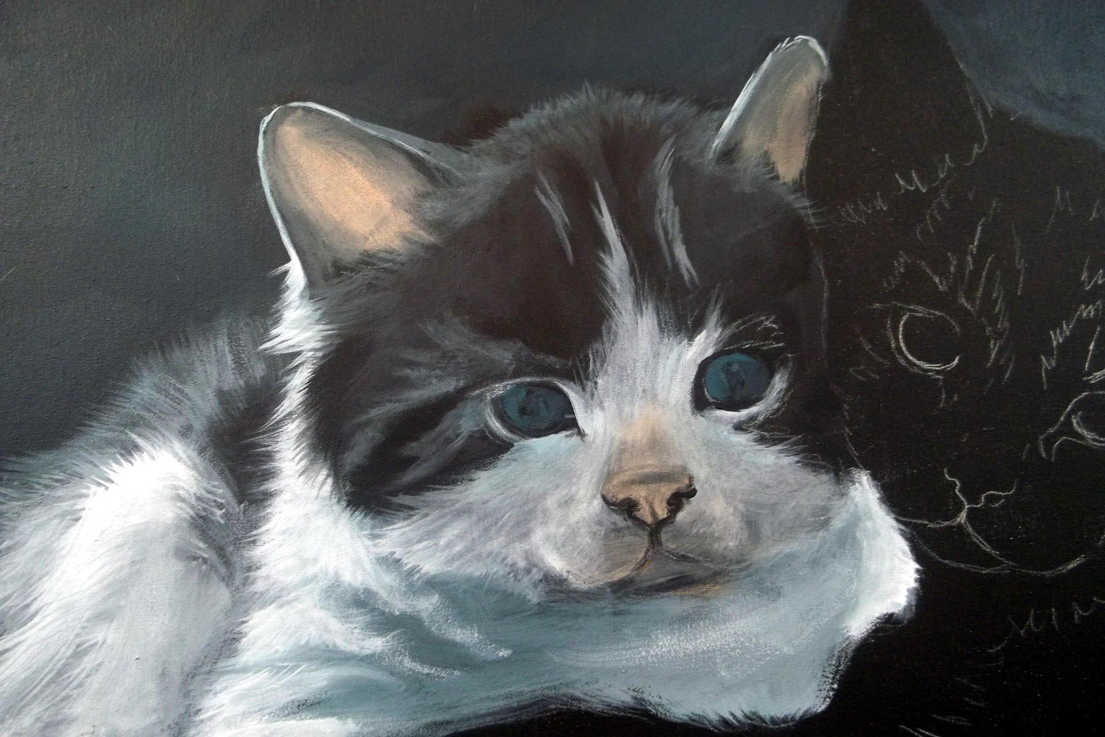
KITTEN #2:
Block in the rust areas on the kitten using the same mix as above. Use the # 12 Wave and pull the strokes in the direction that the hair grows. Flip small hair strokes into the background. You may wish to use the #8 Wave for this.
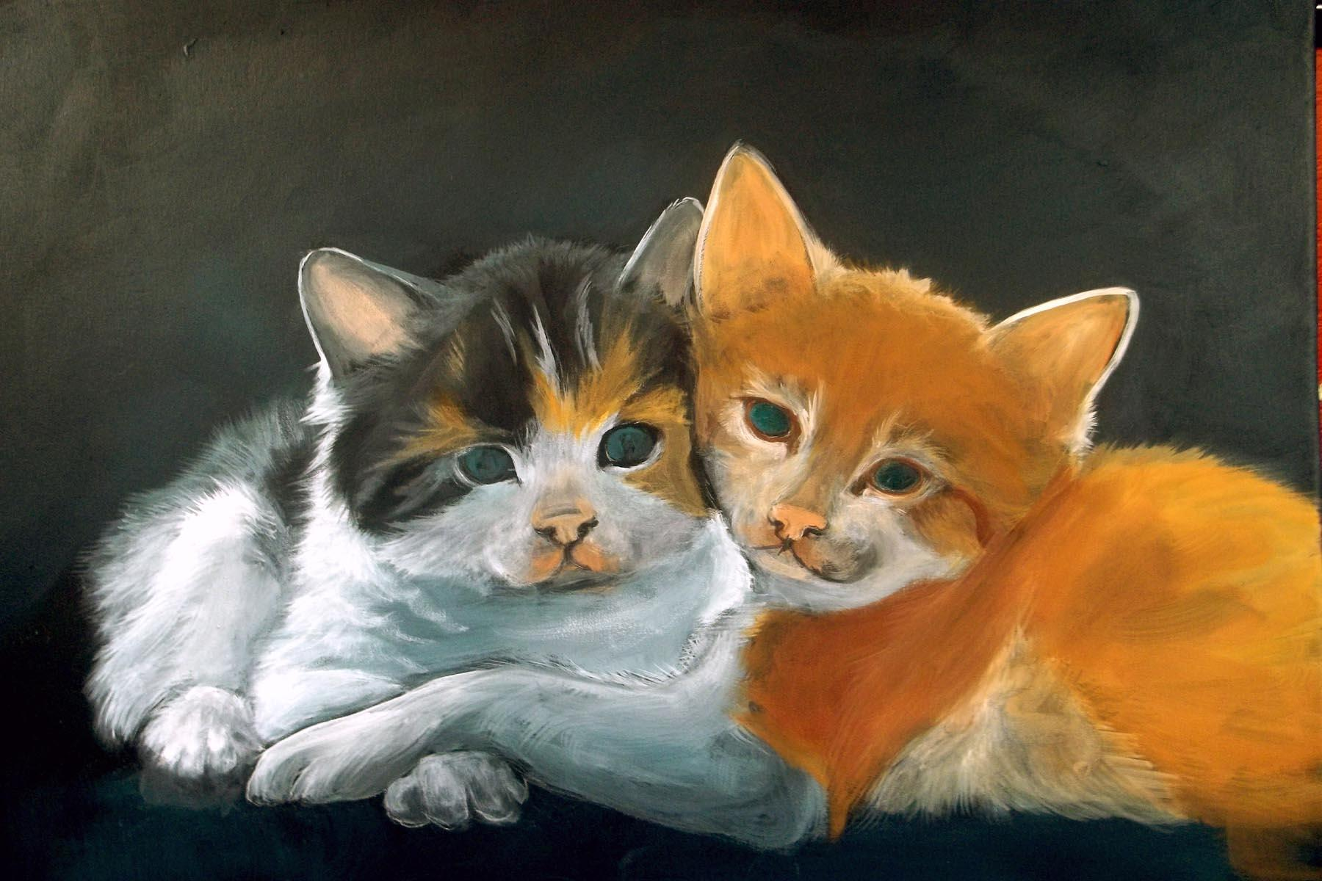

Make a mix of Light Grey + touch of Aqua and a little Opaque White. Block in all the values just as you did on the first kitten. Add the light areas with Opaque White and be sure to flip hair strokes where one color touches another.
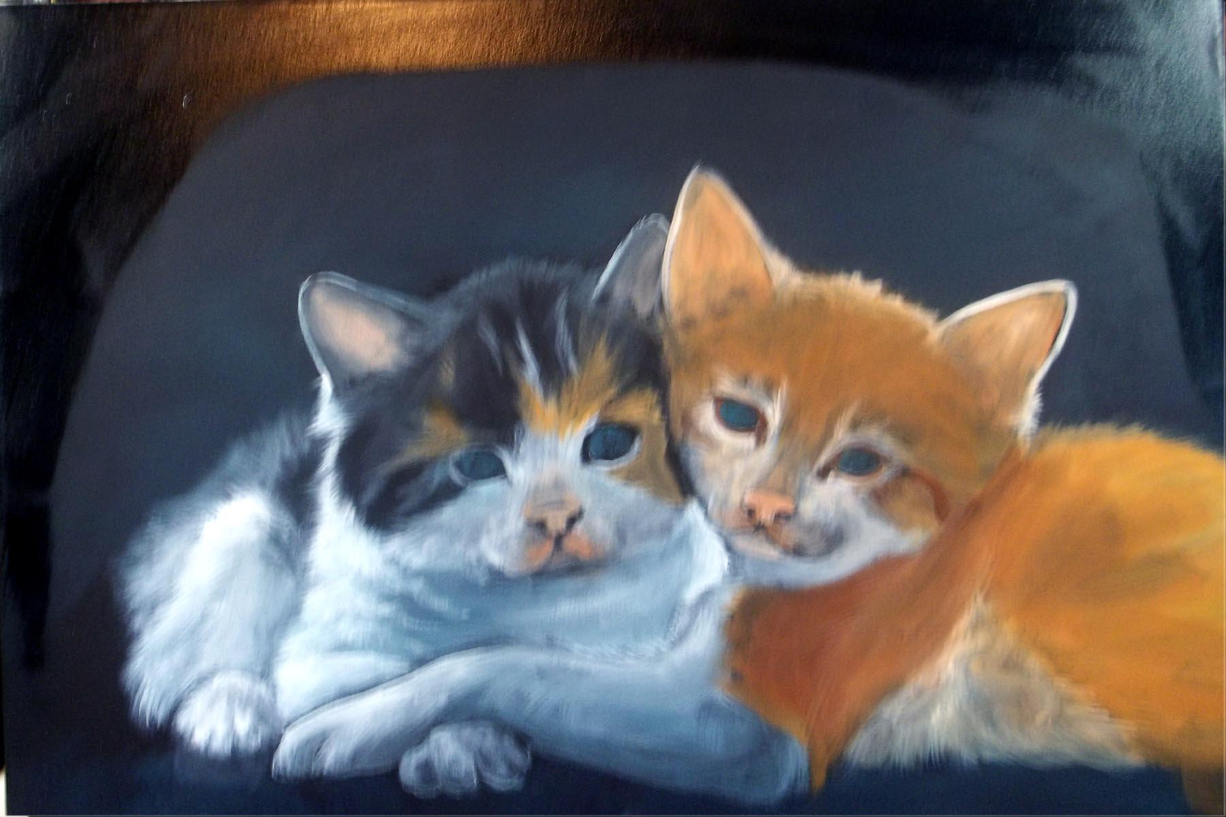

Outline the ears with the small shader and Opaque White. Fill in the inside of the ear shafts with White + Burnt Sienna + a touch of Orange.
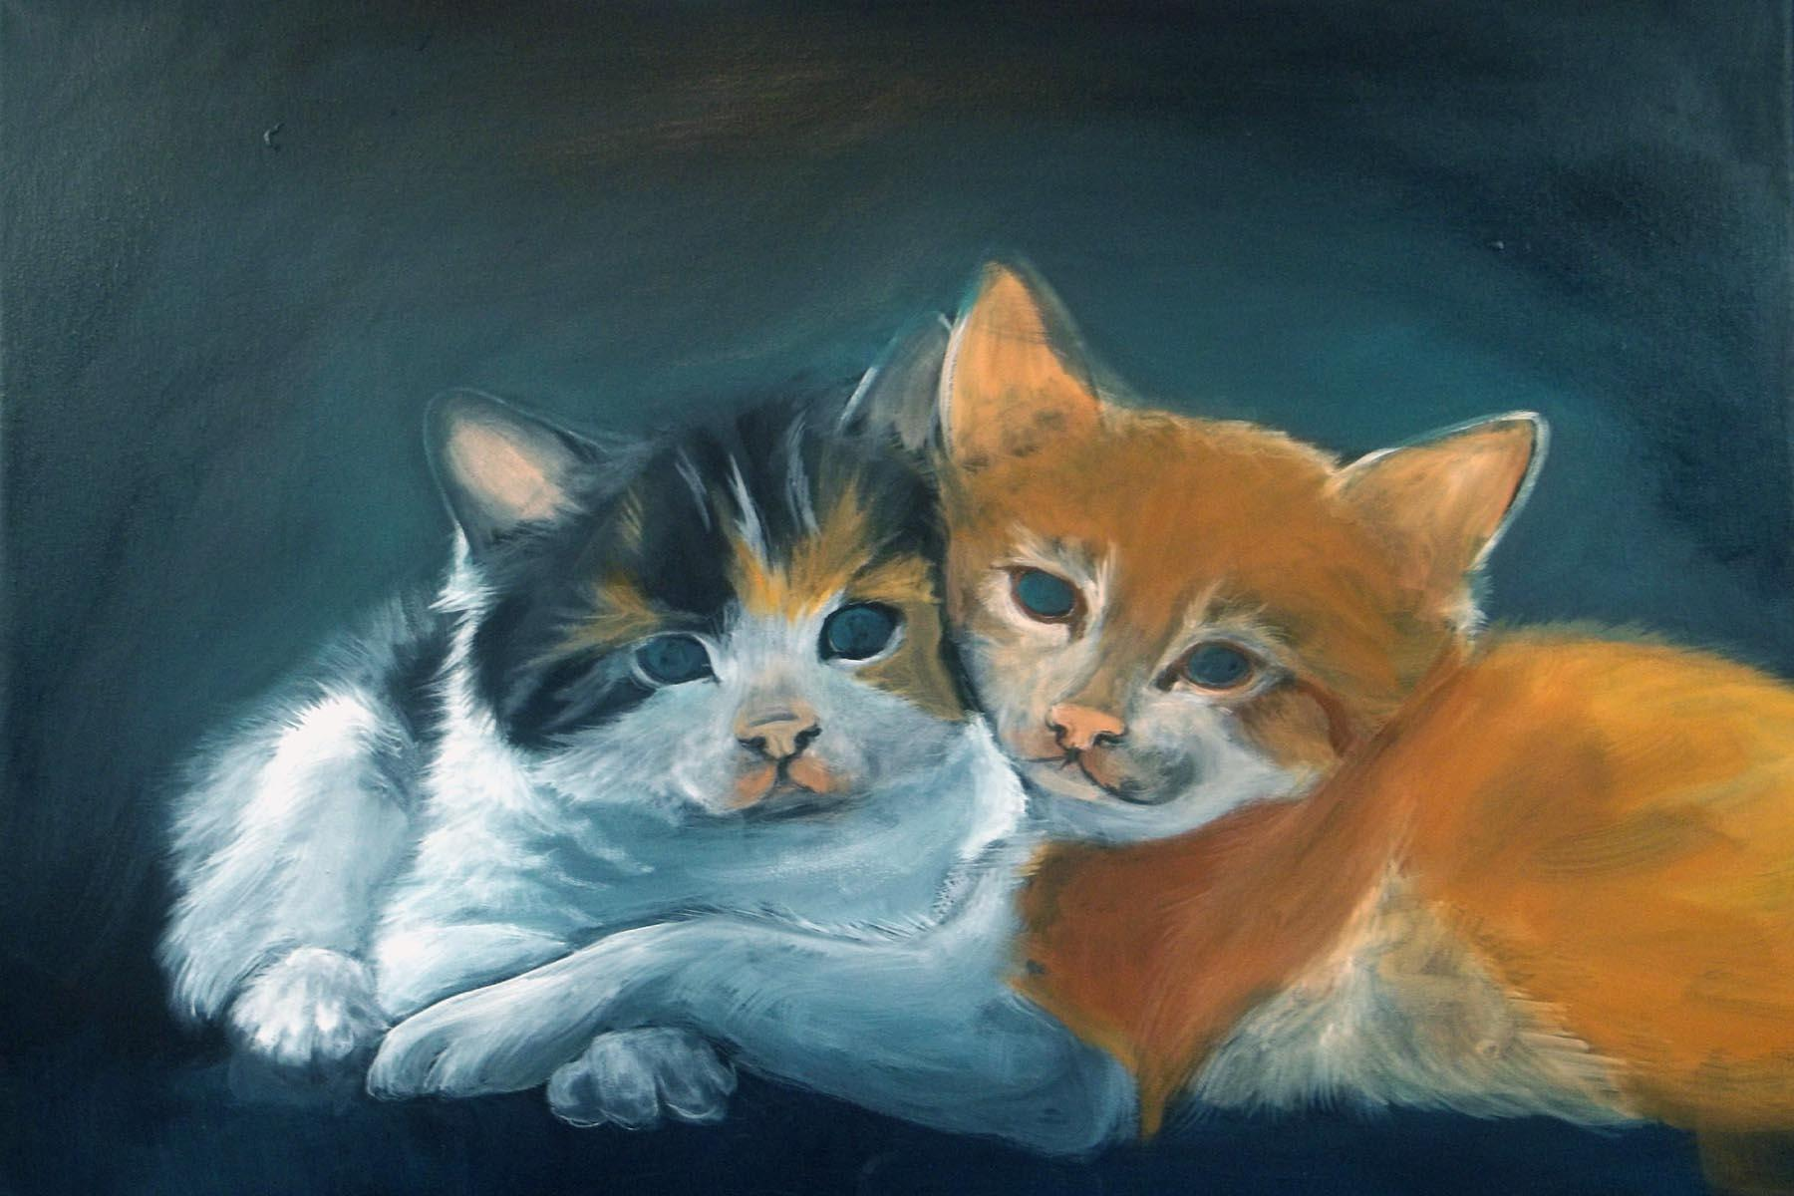

Base the middle values of the coat with Raw Sienna + Burnt Sienna and a touch of Perinone Orange. Use the 12 Wave and be sure to flip hair strokes where one color touched another.

Add more Medium White to the mix for the lighter areas and for the dark areas and Burnt Umber. Again, use the Wave brushes and flip the hair strokes. Refer to your reference photos for value shape, size and direction. You may wish to draw in the stripes with the white charcoal pencil.
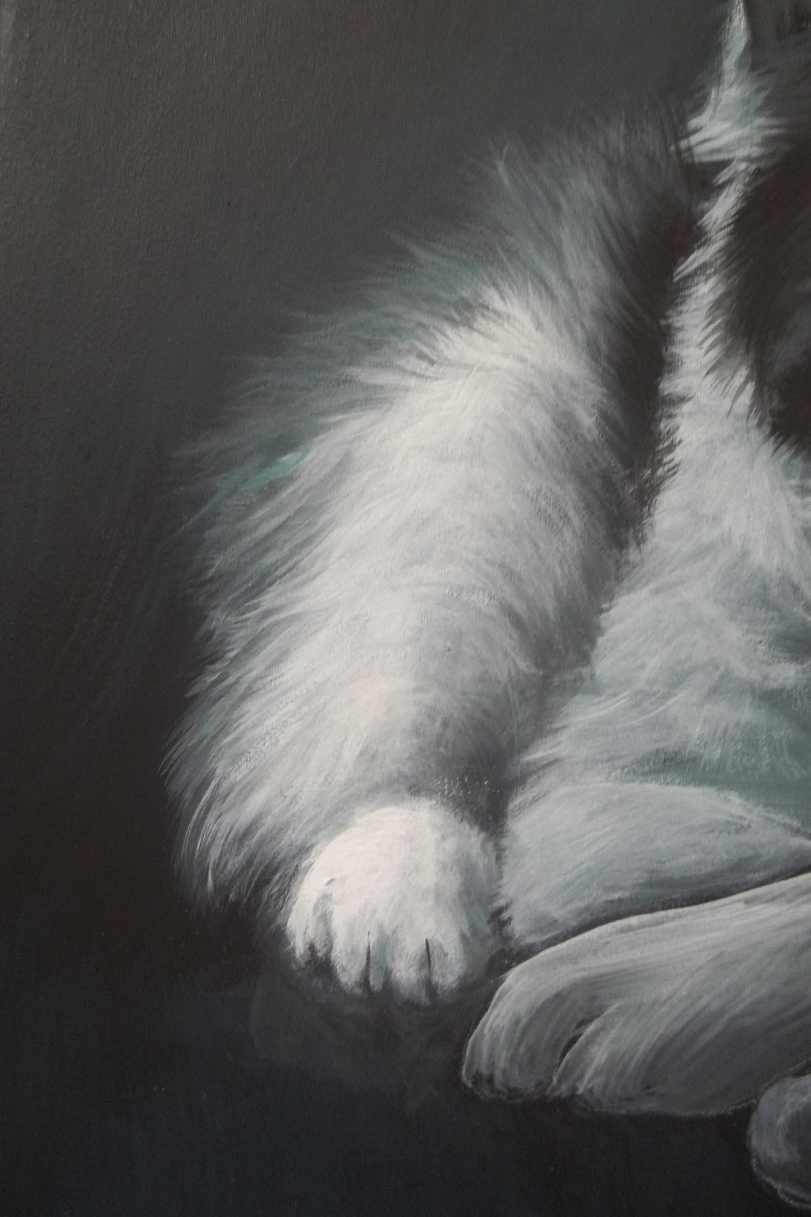

Once you have both kittens blocked in you can go back and finish the background. Start by going around the edges with the big brush and Carbon black + a touch of Aqua.
Then work in some Aqua + a little Light Grey + a touch of Black and work it in around the kitten’s heads and backs. Use the Flat Wash brush and the X stroke to blend the values together.
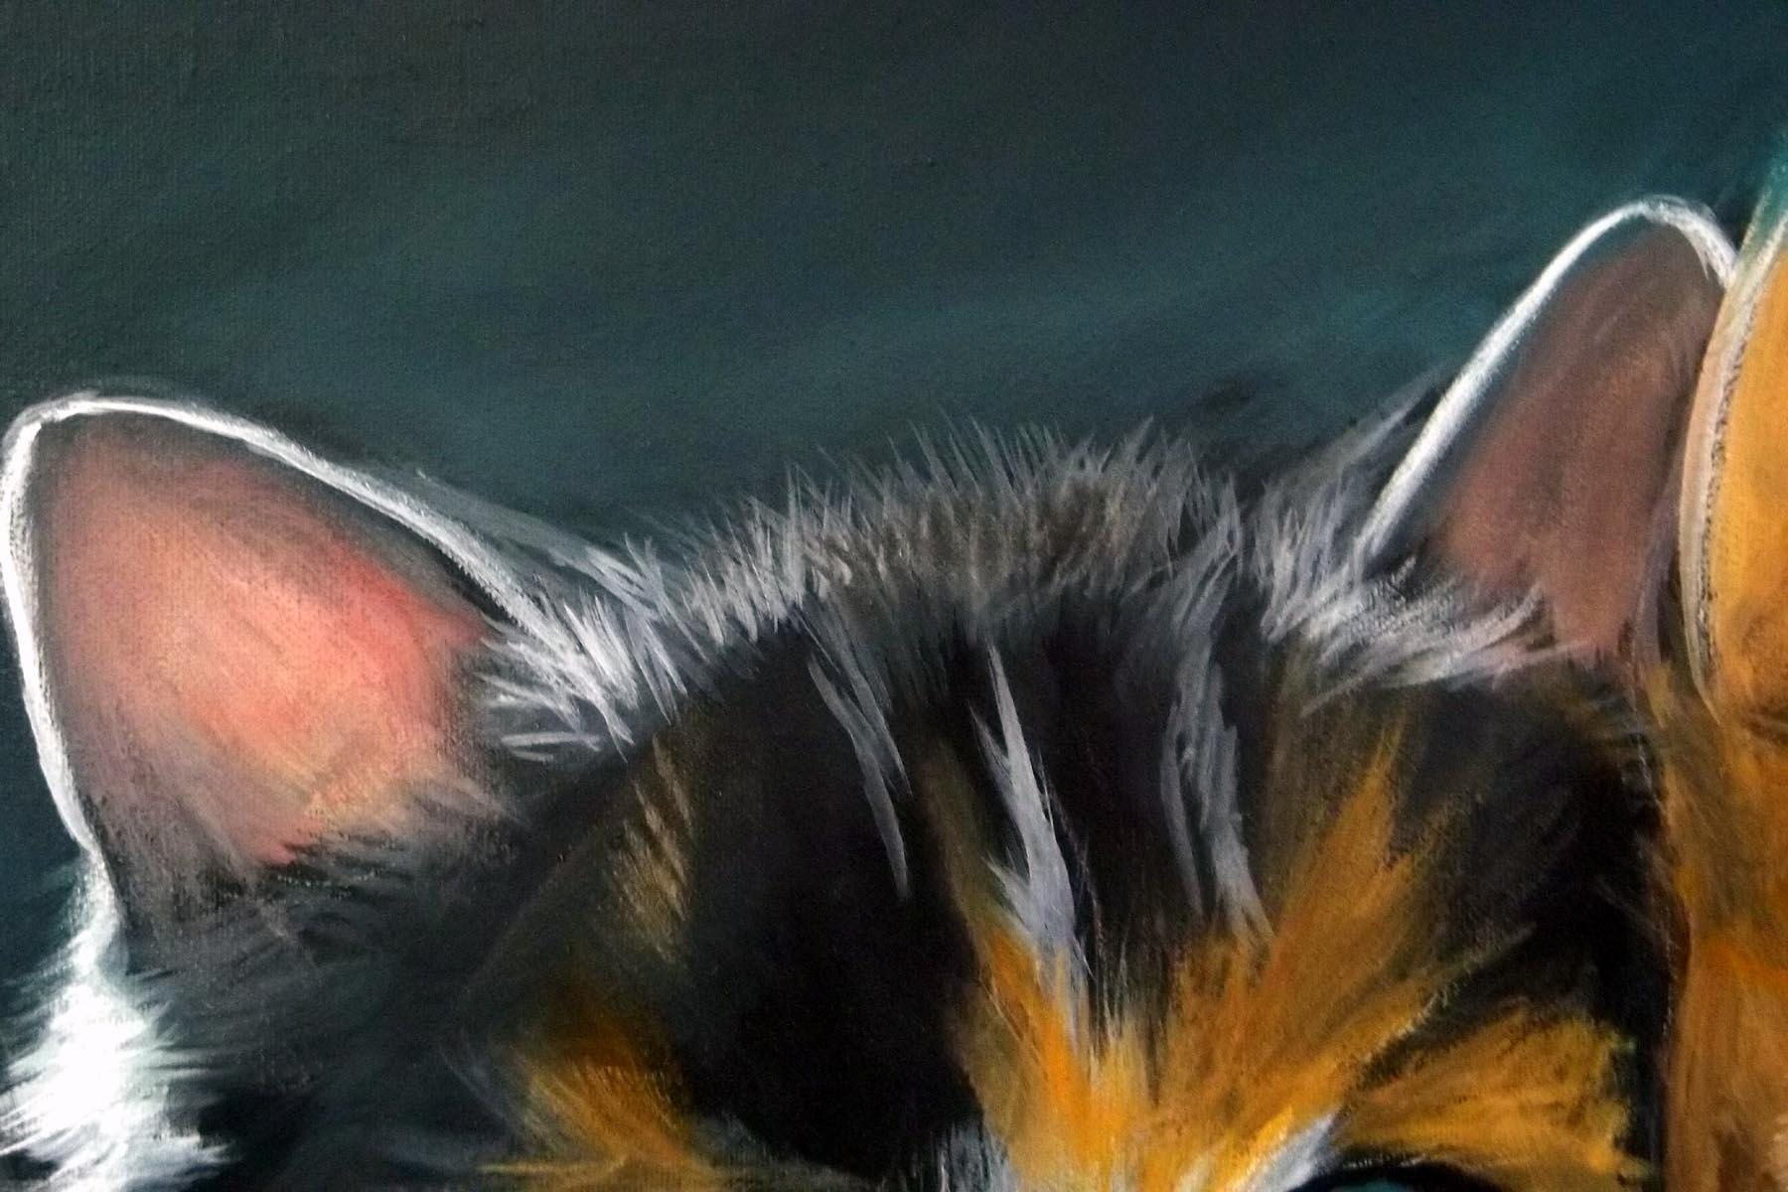

let the background dry so that the colors will blend naturally while drying.

Start on Kitten 2. Work on the hind leg and the back using the same colors mixes that you use to back him in with. Apply a thick mix of paint and the wave brushed and work the values together with the hair strokes. Add the dark areas with Carbon Black and a touch of Aqua.
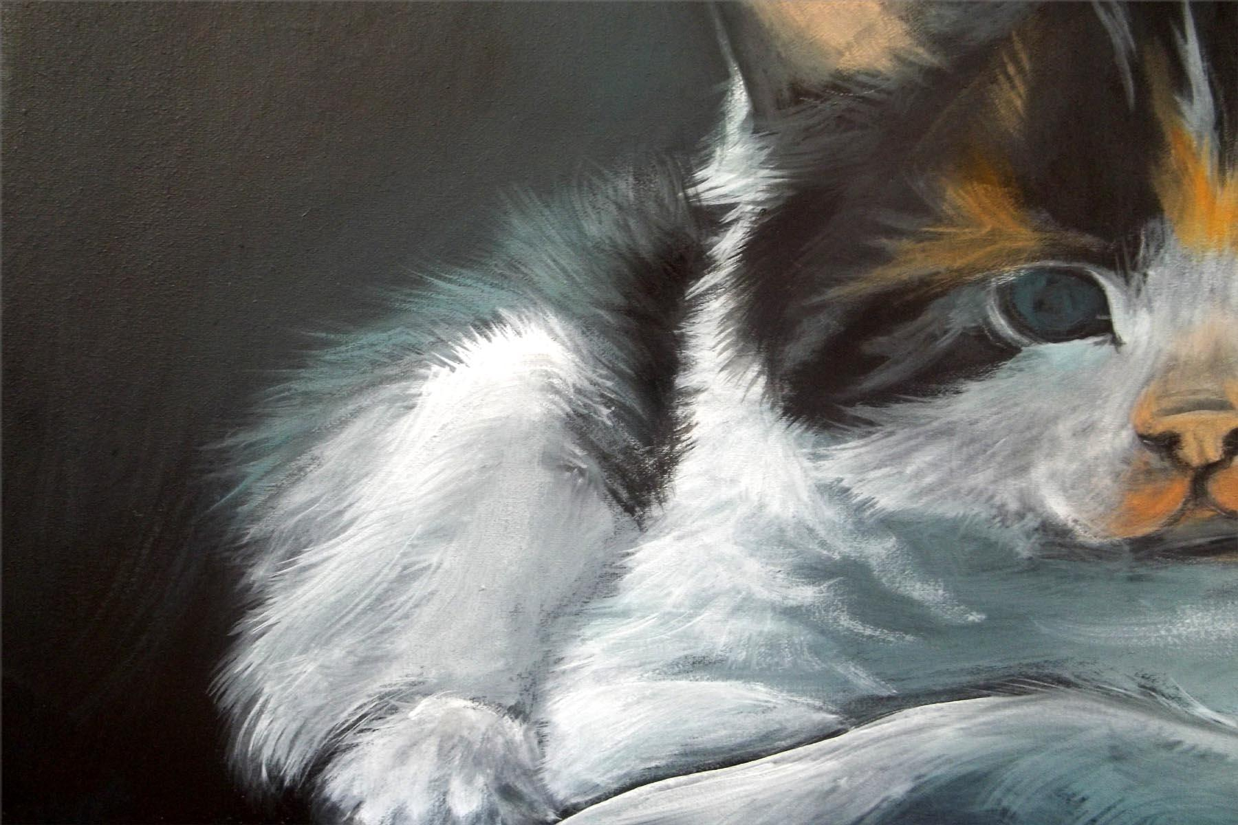

Add the light areas with pure Opaque White and blend the edges. Be very careful of where you place the brightest with on the hind leg and also the shape as this his leg bone. Add the shading with the dark mix and take note of the hair length and direction.

Go over the inside of the ears with Opaque White + Quinacradone gold. Go over the white edges again. Add some of the dark shadow mix to add the shading to the inside of the ears.
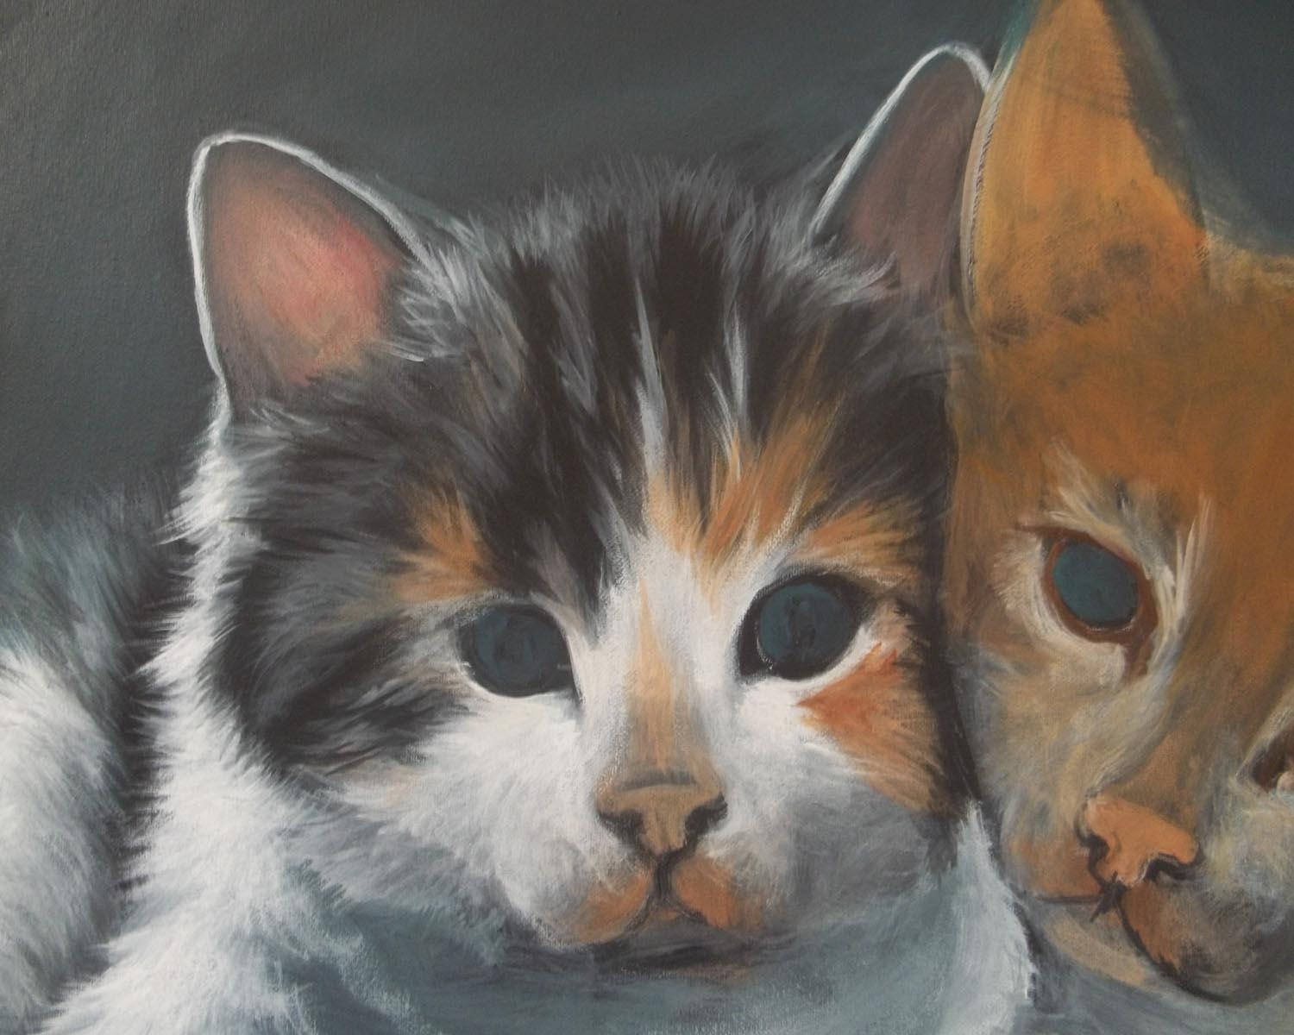

Use the Wave #8 and White to flip in the tiny hair strokes at the edge of the ears and the top of the head. Pay close attention to the shape of the head. Add Opaque White to the face them add the black marking with the # 8 Wave. Add the Grey areas with Light Grey + a touch of Black. Add the rust colored areas with Quinacradone gold + a touch of Raw Sienna + a touch of Medium White.

Outline the eyes with the round brush and Black. Be careful to get the eye the same size and shape. Go over the iris again with Aqua + a touch of Light Grey. Add the pupils with the small #4 Shader and Black. They are a vertical line and NOT round. Add a bit of Aqua + a touch of White to the outer edge of the iris for highlight and add the bright highlight with the round brush and Light Grey. Keep the dots small. Use the round brush and a small amount of Burnt Sienna + a touch of Dairylide yellow to the tear ducts.
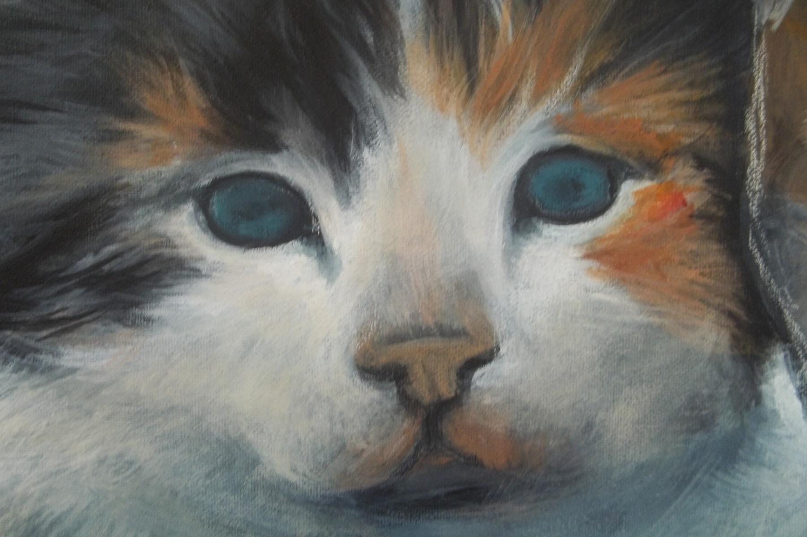

Work on the nose next. Mix a little Burnt Sienna + White to make a pale pink. I find the this is the most natural pink for inside of animal ears and noses. I use it all the time for my animal paintings. Add this pale pink to the tip of the nose and a little around the mouth area, use a dry brush (Shadow Dancer works well for areas like this) and blend the outer edges by gently rubbing in a circular motion. Use a dry brush and a bit of Light Grey + a touch of Black (this should be a very subtle value) and lightly tap in the areas where the whiskers grow. I used the # 4 Shader for this.
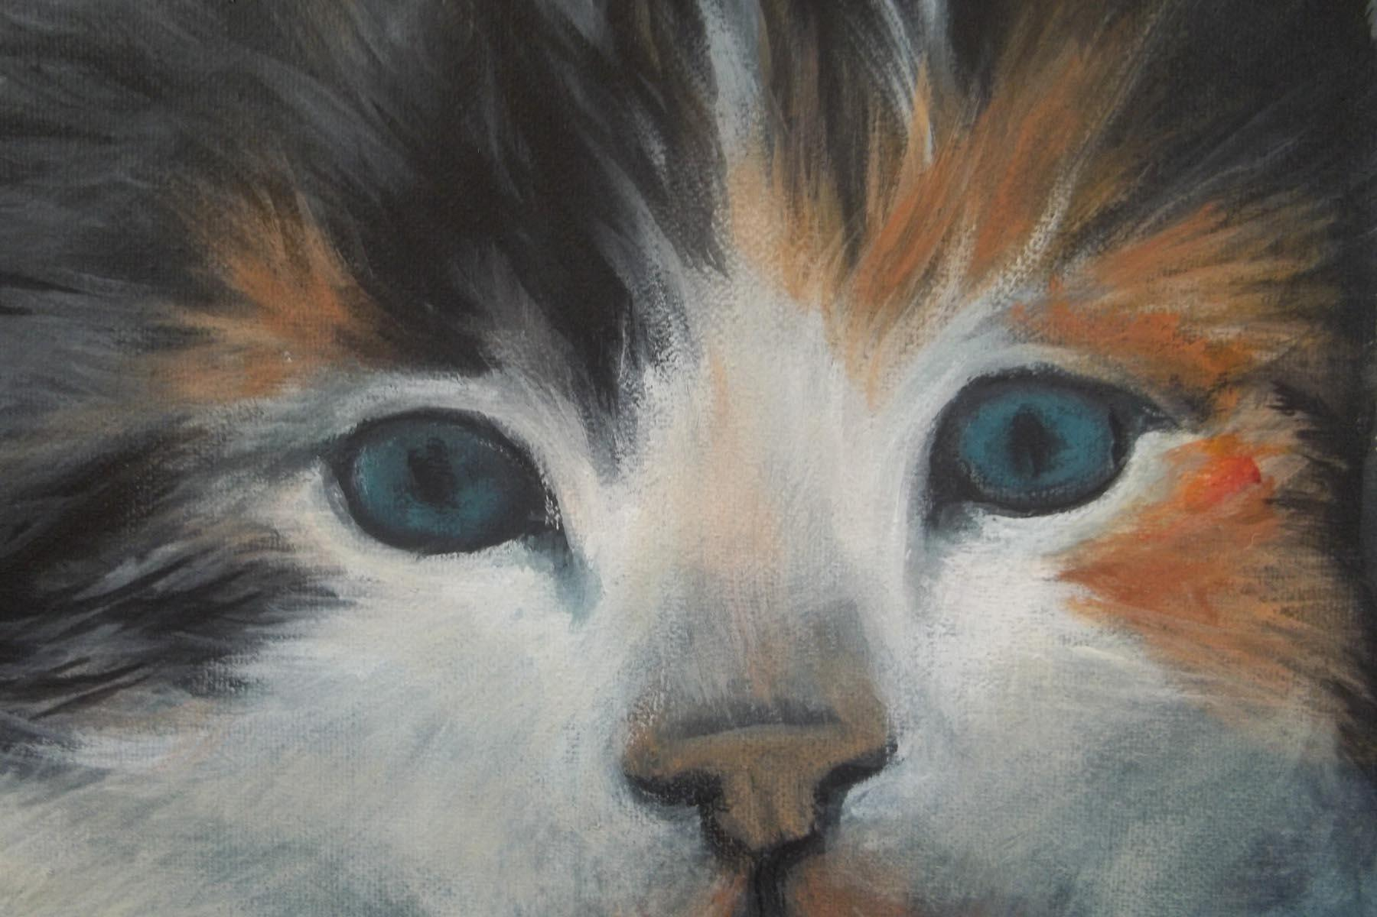
Work in the contours on the bridge of the nose and around where the nostrils are. Use the Round brush to add detail. Add the nostrils with a bit of Black. Add the lightest areas with White.
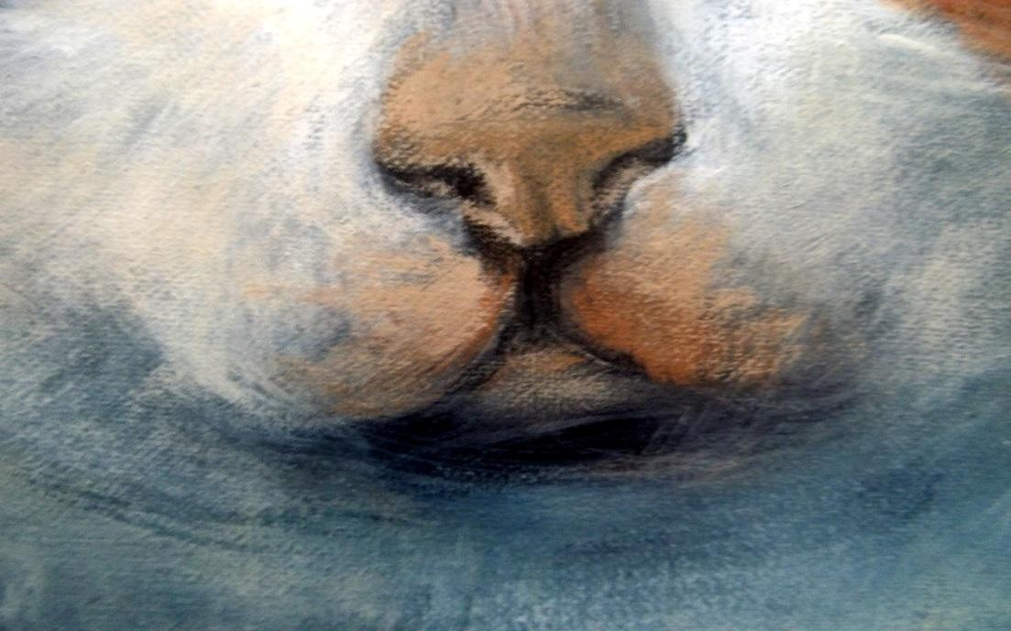

Now you will finish the chest. Use the # 12 Shader and the medium value of White + Light Grey. While wet ad a few White highlights with the #12 Wave brush.
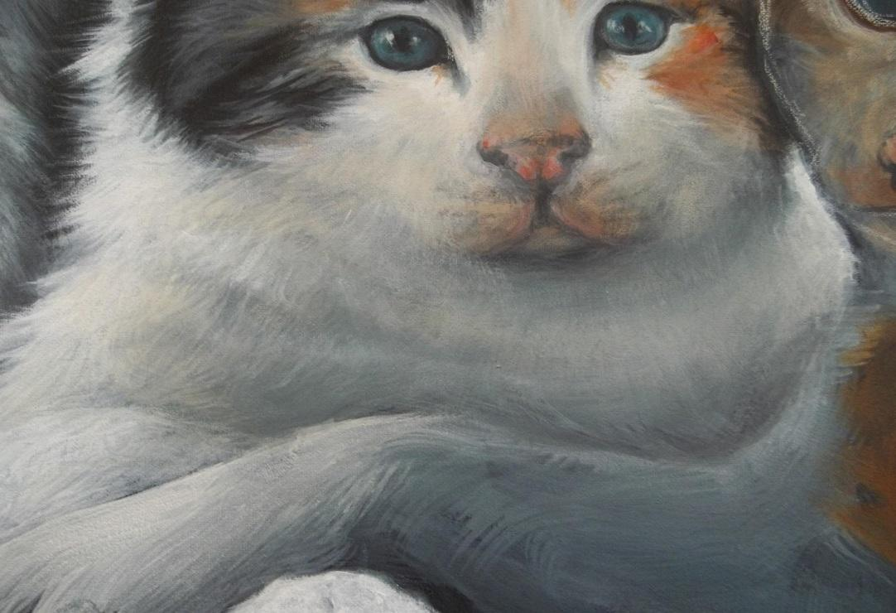

KITTEN # 2:
Make a mix of White + a touch of Dairylide Yellow + Touch of Perinone Orange. This should be a very light color mix. Paint the inside of the ears. While we add the shading with a dry brush and a mix of Burnt Umber + Light Grey. This should be a medium value and be sure to blend well with the first application of paint. Go over the edges once again with Opaque White and add the tiny hairs with the # 8 Wave and the round brush. REMEMBER! DO NOT OVERLOAD THESE BRUSHES AND DO NOT USE TO MUCH WATER,
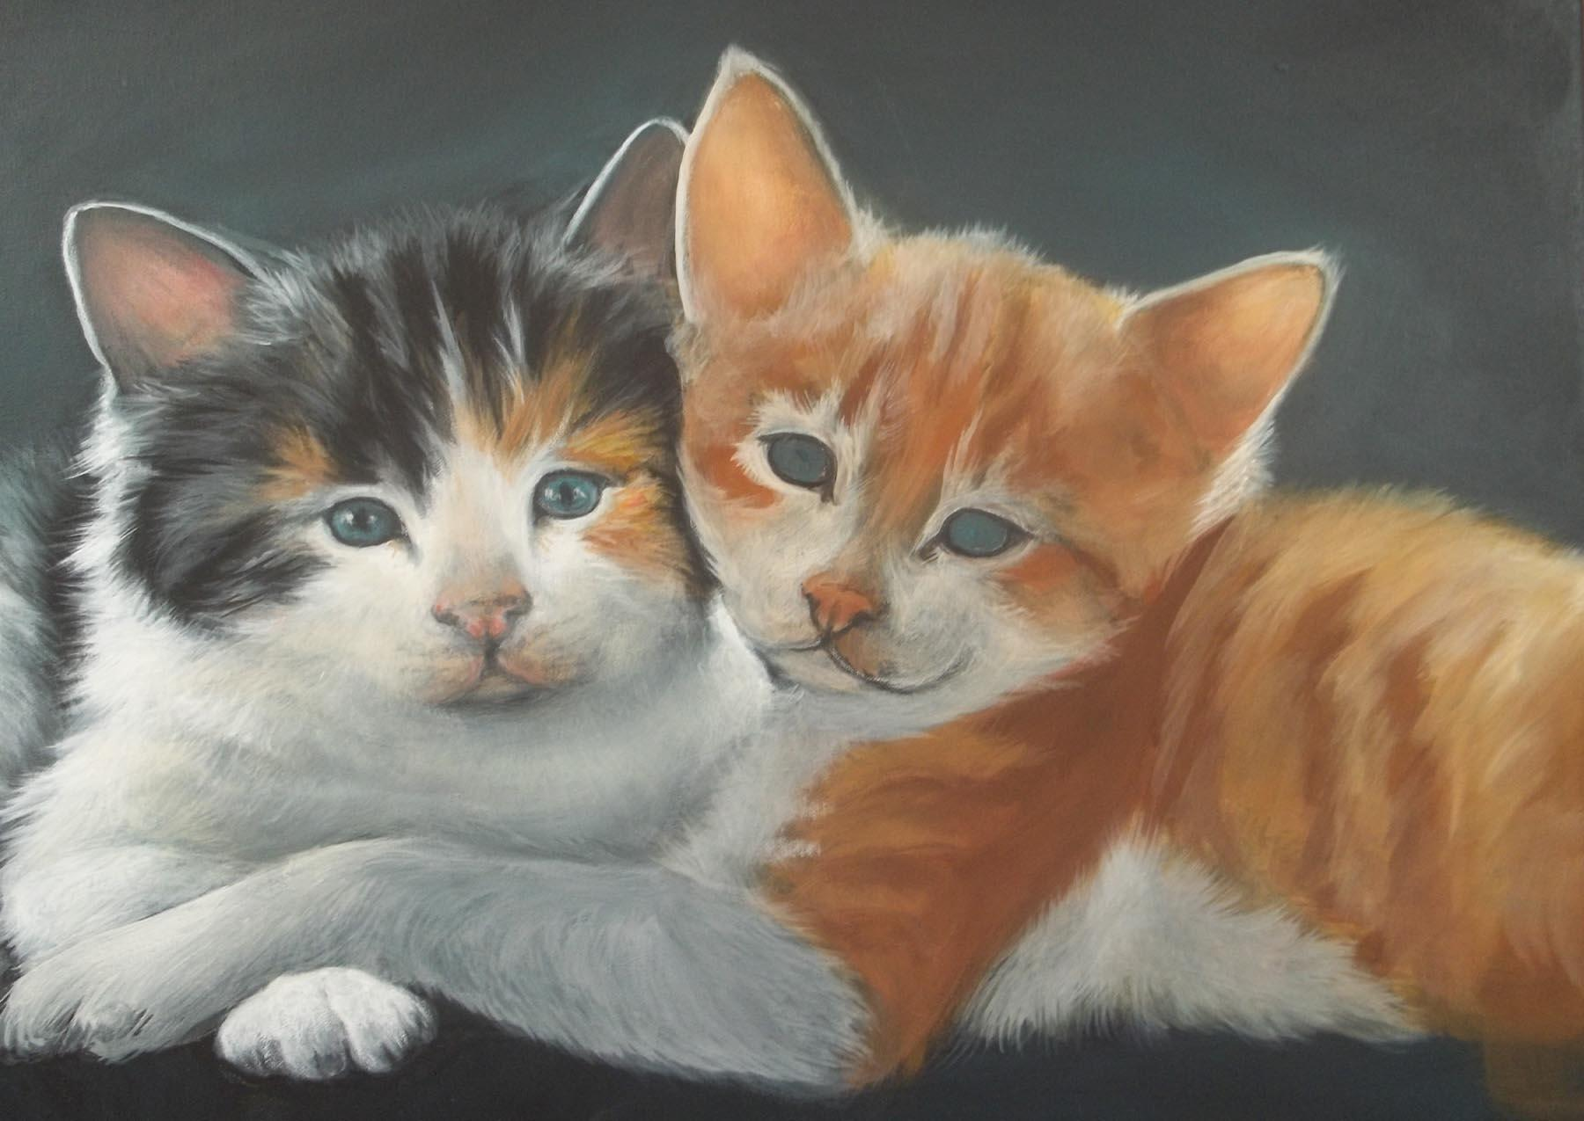

Mix together Raw Sienna + touch of Burnt Sienna and Medium White. This should be your medium value for the kitten. Use the # 8 or 12 Wave Brush to add the medium light areas on the head. Loosely work in the dark shapes with the same brushes and Burnt Sienna + Burnt Umber + Raw Sienna. Refer to your reference photos often!
Add the white areas with Opaque White + Light Grey and let dry.
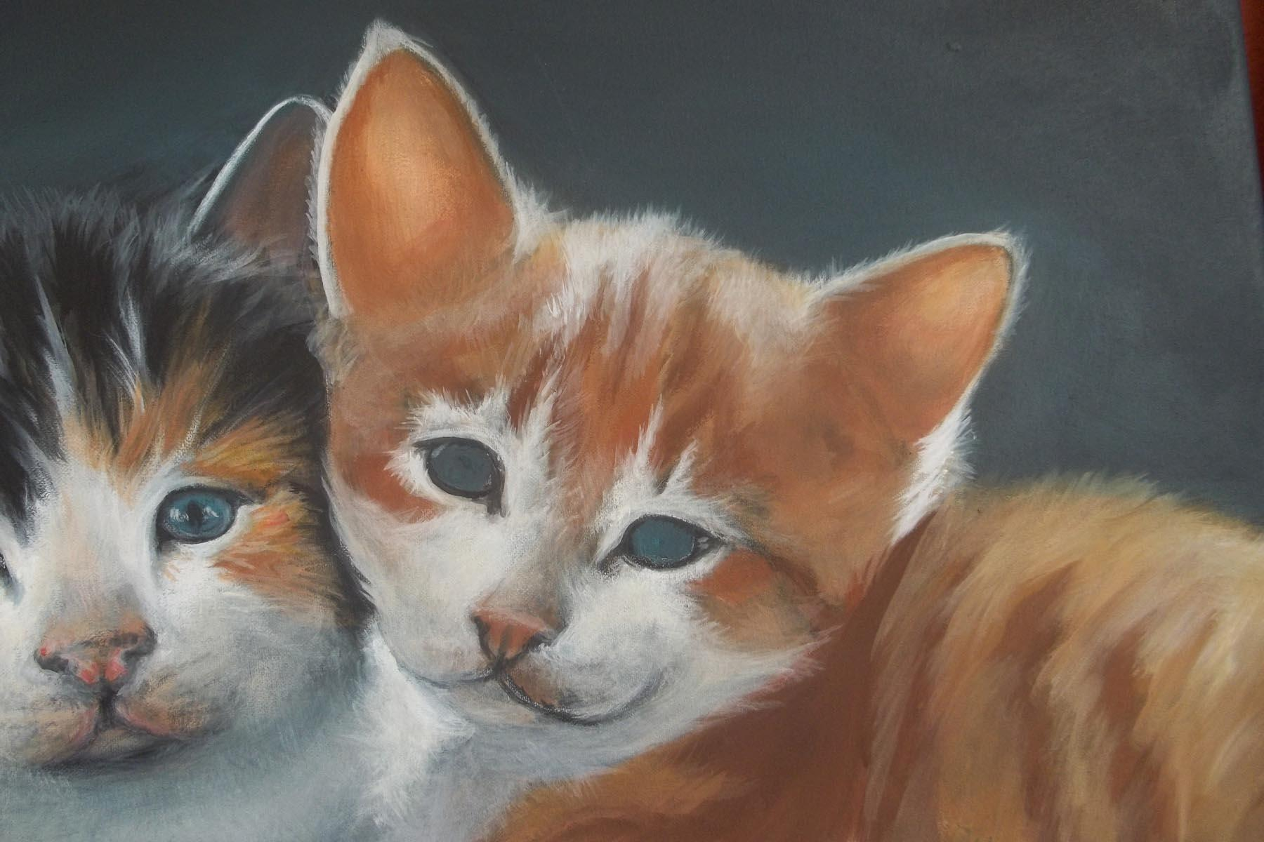

Go over the white areas on the face and ad the highlight with pure White. Pay close attention to the value changes, also add the bright White on the leg and the paw. Use the Wave brush to flip little hair strokes where one value touches another. Use the wave brush to add the half tones on the chest and the leg. Notice the direction of the brush strokes. They should go the same direction as the hair grows. Use a light touch and very little paint. Let dry.
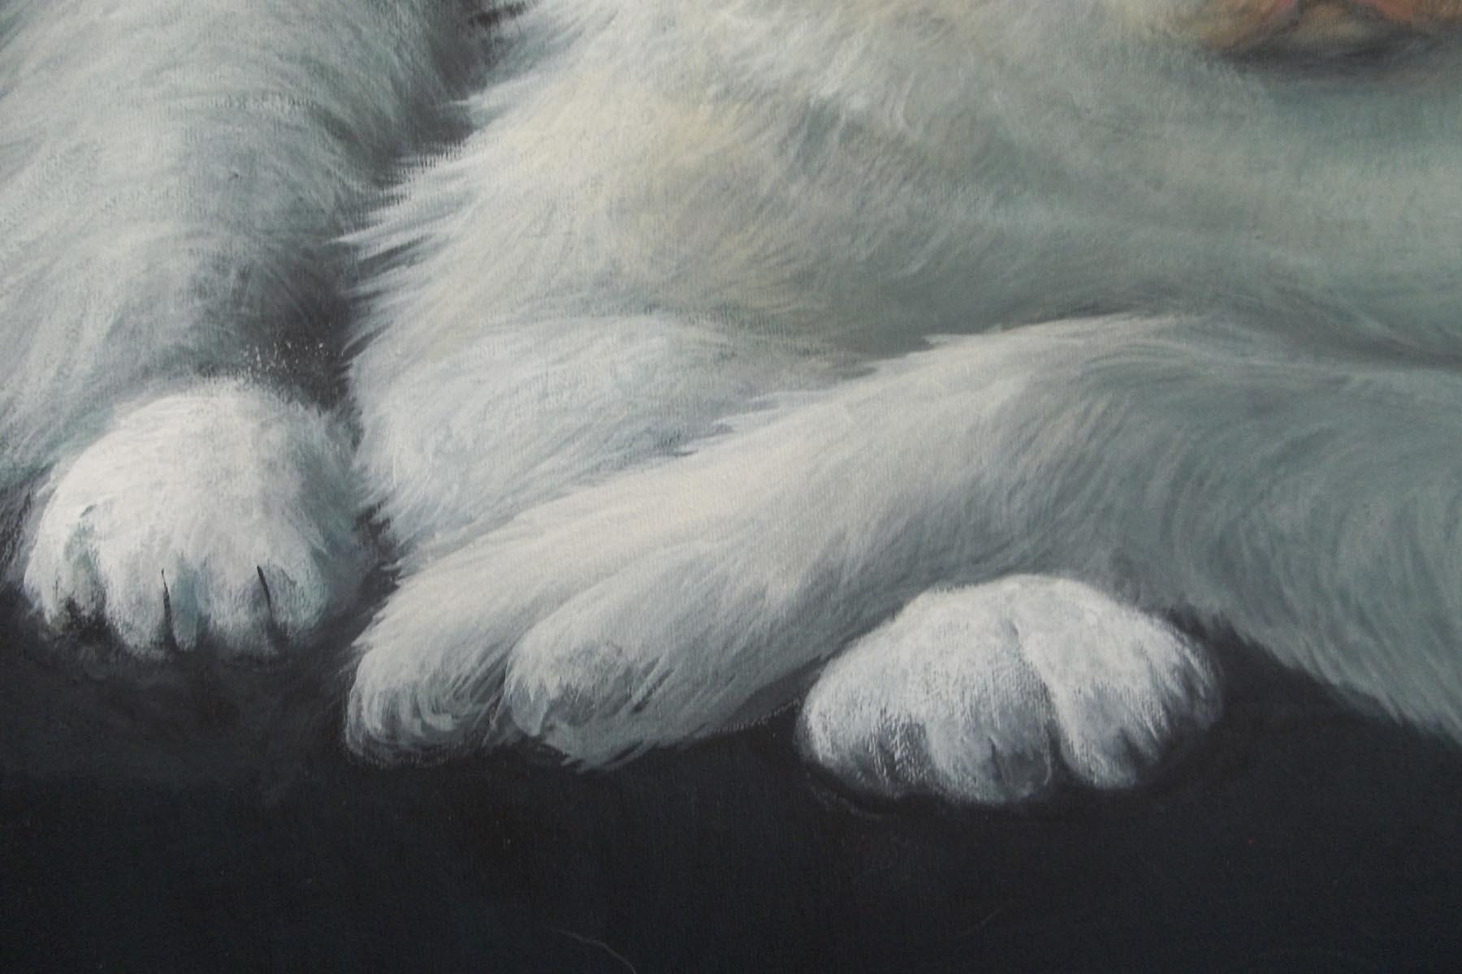

Use Raw Sienna + Burnt Sienna + a touch of Perinone Orange + a touch of Burnt Umber and using the # 4 Shade start working in the dark Stripes on the face. Lightly flip tiny hair strokes at the edges of the stripes.

Use the Same mix of color and the #8 Wave and add the stripes on the body. WATCH YOUR HAIR DIRECTION AND LENGTH!
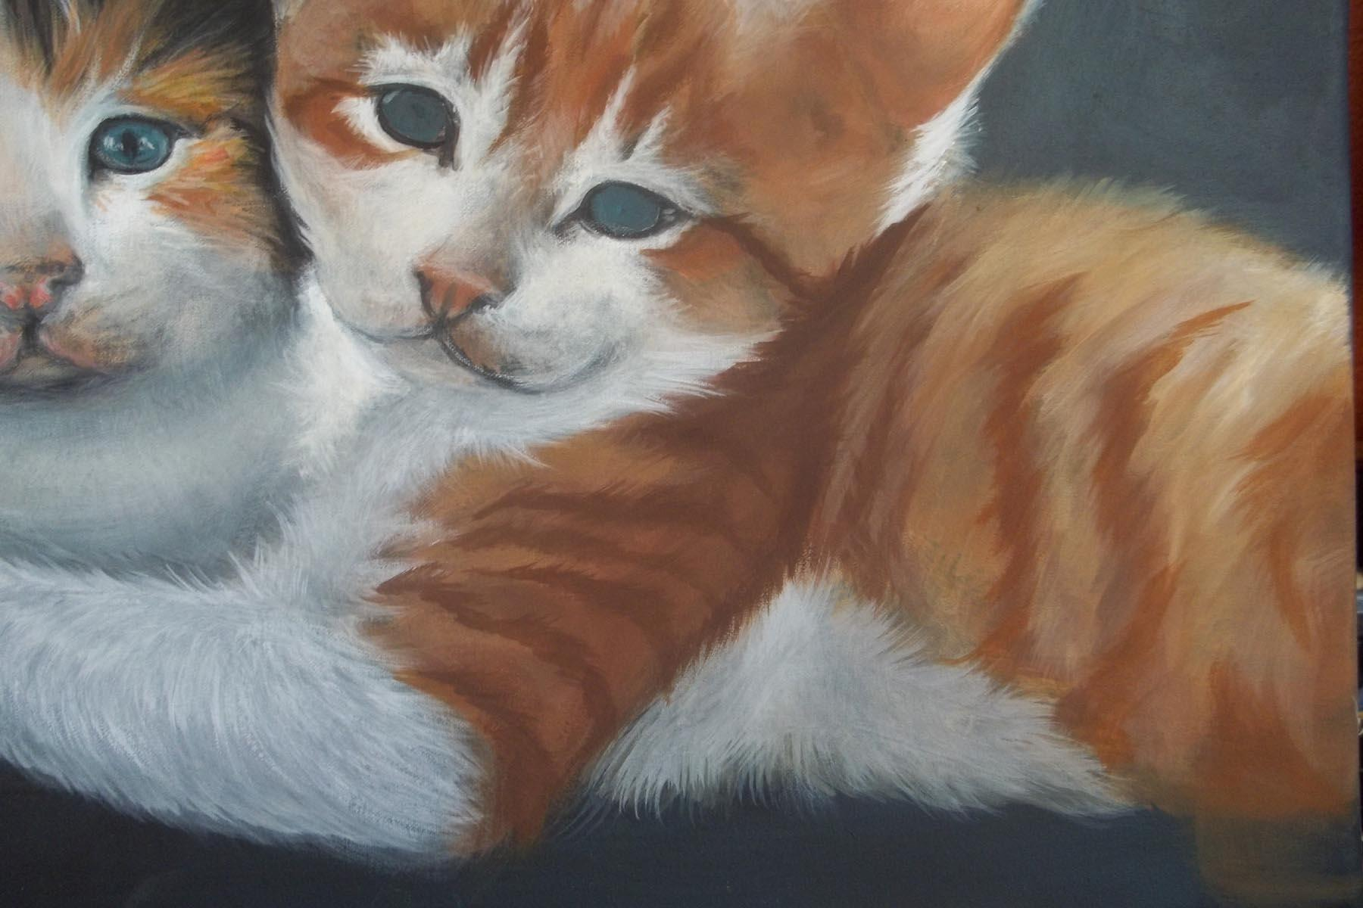

Add the light hair on the body and the head area with Raw Sienna + Medium White and the #8 Wave. Keep the light color toward the upper part of the head and back.

Add the dark value with Burnt Sienna and Burnt Umber. Notice that I have darkened these stripes more towards the bottom.

Add the dark shadow where the head touches the back by using the dark mix + a touch of Black.

Paint in the White area on the belly with the Raw Sienna + Burnt Sienna + a touch of Medium White. Add the stripes and hair strokes. 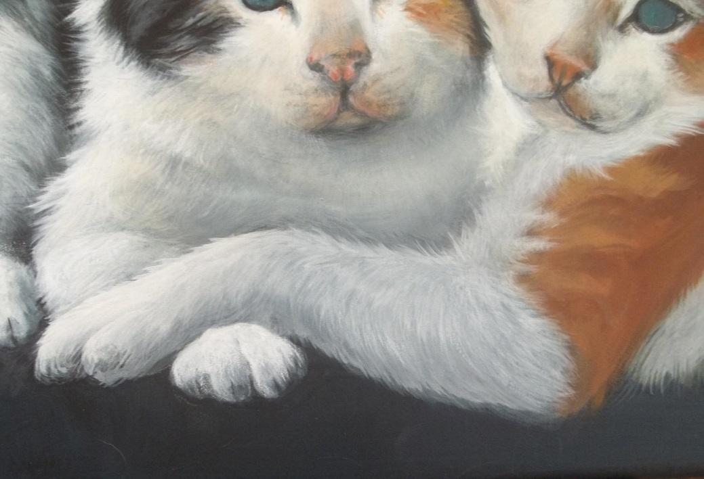

Outline the eyes on Kitten 2 with Black and the round. Fill in with Aqua + Light Grey and add a little lighter value on the left edge of the Iris with the Aqua + a little more Light Grey. Add the pupil with the # 4 Shader and Black. Use the round brush to add the highlight with Light Grey,
Use the White Charcoal pencil to draw in where you wish to place your whiskers, Use the round brush to add the whiskers on both Kittens. When the paint is dry use a moist paper towel to remove the Charcoal lines that show.
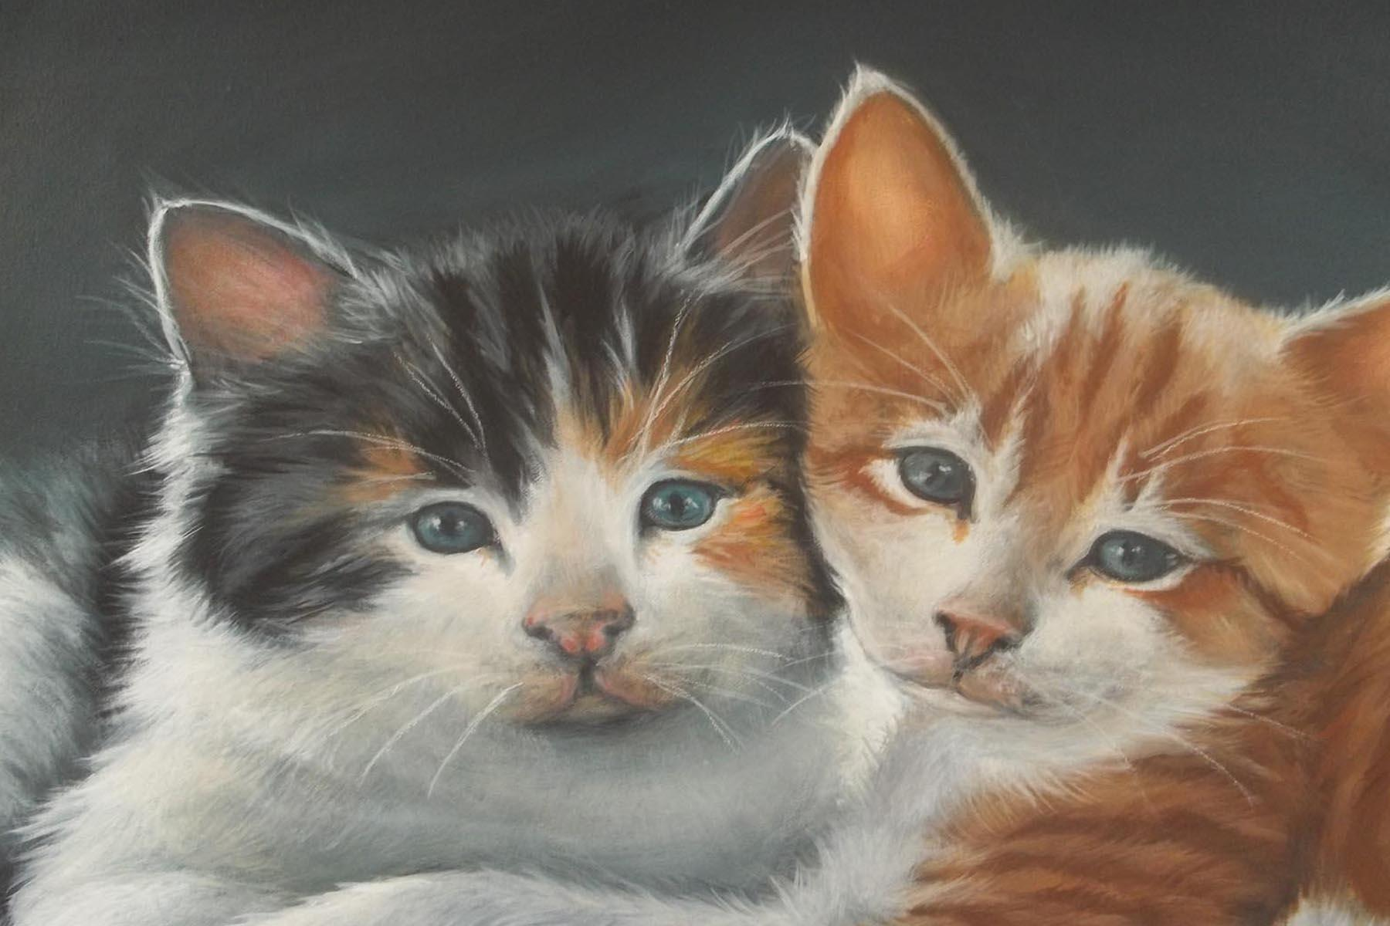

Use the # 12 Shader and a mix of Aqua + Light Grey + a little Opaque White and with a lightly loaded brush add a little color under the kittens to anchor them down. Do not over do this as it will take away from the kittens. Keep the brush dry.
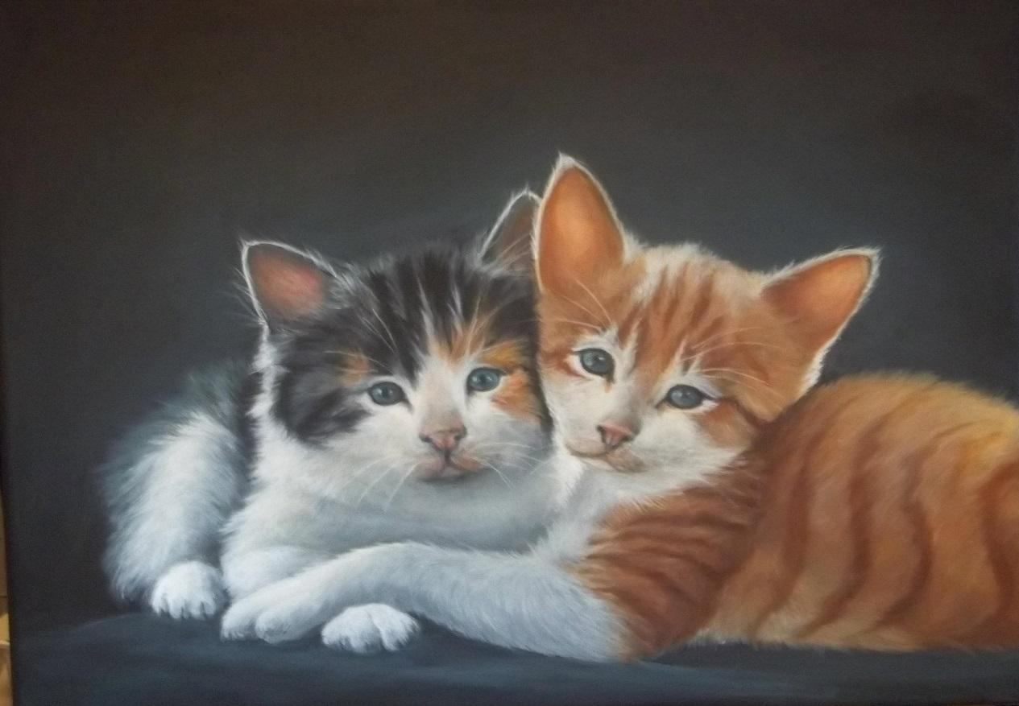

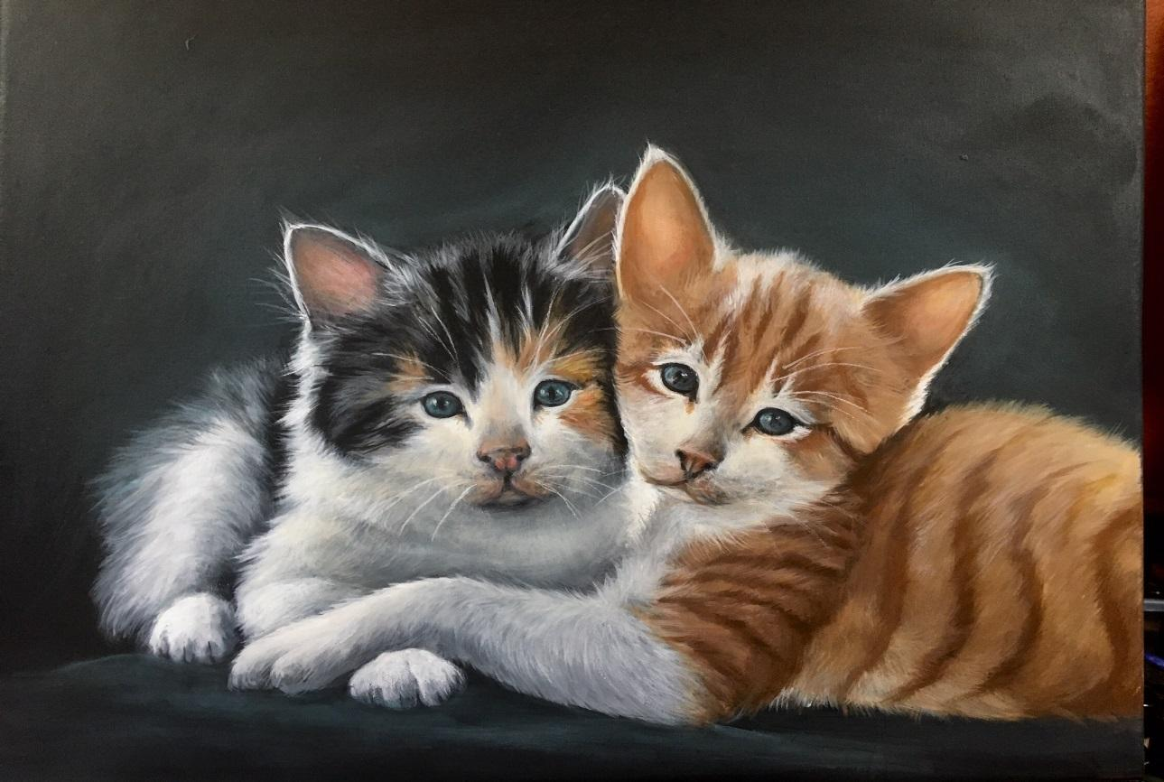
Your painting is now completed, and I hope that you have enjoyed this project and learned some new techniques. When your painting is dry, I recommend that you apply a protective varnish., this will add depth and make your colors pop.

