Celebrate Fall
by Marlene Fudge CDA

Paints:
DecoArt Americana Acrylics
Antique Gold
Antique Green
Antique Maroon
Antique White
Asphaltum
Burnt Sienna
Light Buttermilk
Plantation Pine
Soft Black
Terra Cotta
DecoArt Vintage Effect Wash
White
DecoArt Dazzling Metallics
Splendid Gold
Brushes:
Dynasty Black Gold
1” Flat Wash- 206FW
#5/0 Liner- 206L
#6 & #810Shader- 206S
#3 Round- 206R
Mezzaluna- Medium
¼” Dynasty Stencil-Pro Stencil brush
Mediums:
DecoArt DuraClear Soft Touch Varnish
Surface:
12” Round Pallet Plaque (Cupboard Distributing Item #31-L475, cdwood.com)
Miscellaneous Supplies:
Laurie Speltz Fall Stencil (BCS189 Lauriespeltz.com)
Ribbon of choice
Smooth Sponge
Sandpaper
Transfer paper
10” circle to trace (I used a 10” bowl)
Stylus
Krylon 18kt. Gold Leafing Pen
Painting Instructions:
Use the #1 Flat Wash brush to base coat the entire surface with 1 coat of Asphaltum. Let dry well. Using a slightly damp sponge, pounce the sponge into the Vintage Effect Wash.

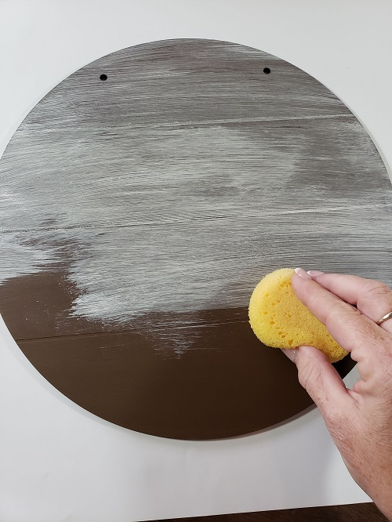
Wipe the color onto to the surface. You want to see some of the background color show through. Let dry well. Lightly sand off a few spots here and there to let the background show through. This will make the piece look aged. Wipe off the excess dust and transfer the pattern.
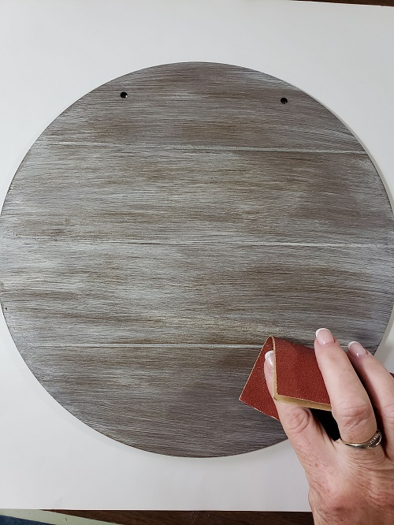

Grass:
Add a touch of water to Plantation Pine to make an inky consistency. Use the 5/0 Liner brush to add the grasses on both sides of the pumpkins. Add a touch of water to Antique Gold and with the liner brush, add a few highlights here and there along some of the grasses.
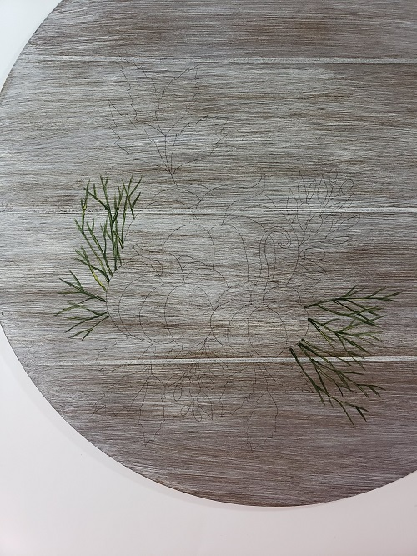
Leaves:
Base coat the large leaves with Antique Maroon using the #6 Shader brush. Use the Mezzaluna brush to dry brush Terra Cotta onto the center of the leaves.
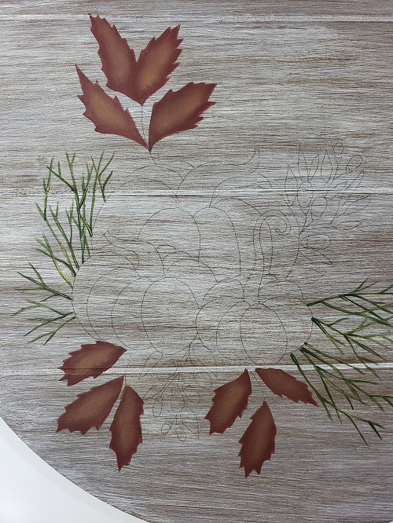

(Hint: To dry brush, load the DRY brush with paint, wipe off most of the paint onto a paper towel. With the remaining paint in the brush, scrub onto the surface in a circular motion. This will leave a soft color to highlight.) Using the #6 Shader, shade along the bottom edge of the leaves with Soft Black. Add a touch of water to Soft Black and using the liner, add the stems and vein lines.
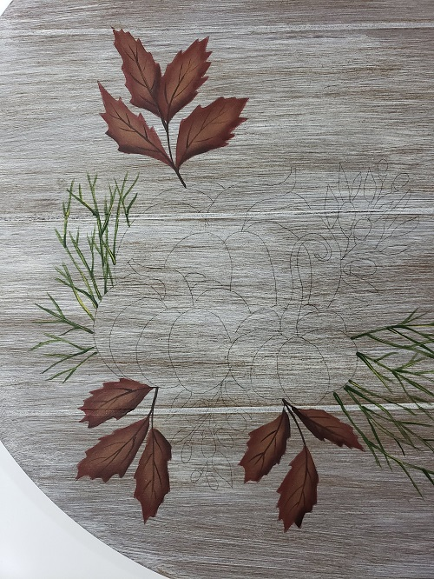

Berries:
Use the #3 Round brush to add the berries with Antique White. Shade along the bottom, next to the calyx, with Antique Maroon using the #6 Shader. Using the liner brush, add a small stroke of thinned Lt. Buttermilk on the top left corner of each berry.
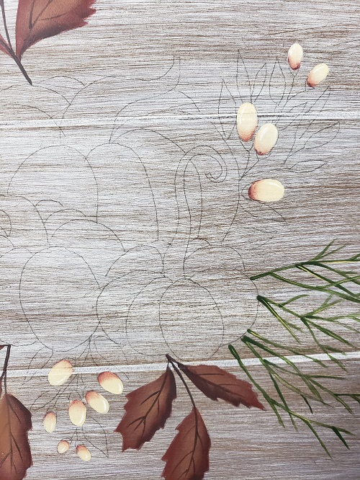

The stems, calyx and leaves are all added with Antique Green using the #3 Round and the liner brush. When dry, shade along the bottom of the leaves and the bottom of the calyx with Plantation Pine using the #6 Shader. Use the same brush to highlight the top of the leaves with Antique Gold.
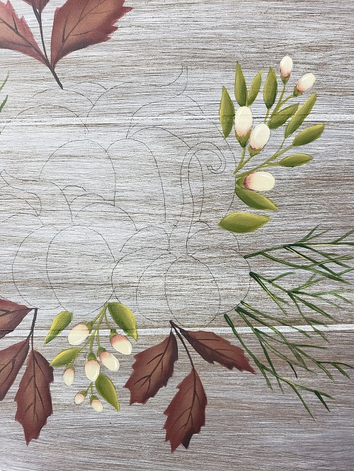

Large Pumpkin:
Basecoat the large pumpkin with Terra Cotta using the #10 Shader. (Paint over the stems of the front pumpkins.) Let dry. Shade along the outer sections of the pumpkin with Burnt Sienna using the #8 Shader. Deepen the shading by floating a smaller section of Antique Maroon along the sections using the #6 Shader. To highlight each section, use the Mezzaluna brush to dry brush a mixture of equal parts Terra Cotta + Antique Gold over the center of each section.
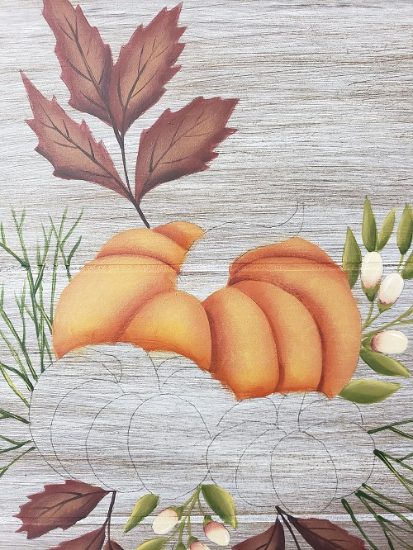

Using the same dirty brush (no water) dry brush a smaller area of just Antique Gold for an extra highlight. Shade along the bottom of the pumpkin where it goes behind the front pumpkins, with Burnt Sienna using the #10 Shader. Base coat the stem with Asphaltum using the #3 Round.
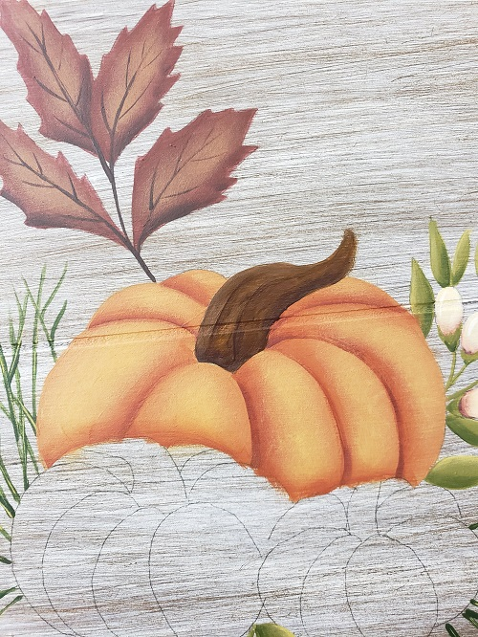

Use the #6 Shader to shade along the bottom of the stem where it goes into the pumpkin and up along the underneath of the stem with Soft Black. Use the same brush to float a few streaks along the stem with Soft Black. When dry, float some Antique Gold highlights along the streaks and on the top of the stem.
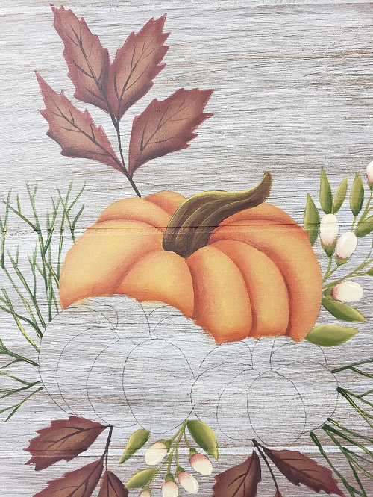

Front Left Pumpkin:
Base coat this pumpkin with Antique Green using the #10 Shader brush. Using the same brush, shade along the outer edges of each section with Plantation Pine. Mix together equal parts of Antique Green + Antique Gold and using the Mezzaluna brush, dry brush highlights onto each section.
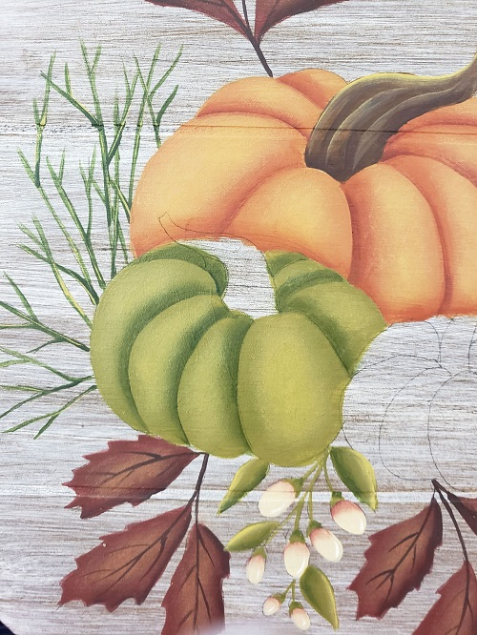

Load the dirty brush with just Antique Gold and add an extra highlight onto a smaller area. Using the #10 Shader, shade along the bottom and the left side of the pumpkin where it tucks behind the front pumpkin with Plantation Pine. Paint the stem in the same way as the back pumpkin.
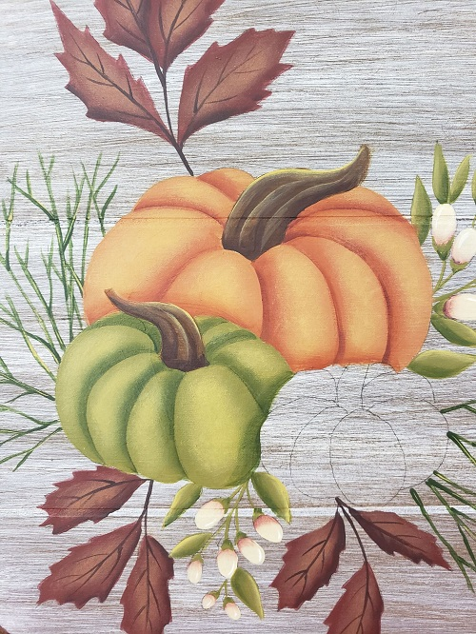

Front Right Pumpkin:
Mix together equal parts of Terra Cotta + Antique Gold. Base coat this pumpkin with this mixture using the #10 Shader. When dry, shade the outer edge of each section with Terra Cotta using the #10 Shader. Deepen the shading with Burnt Sienna using the #6 Shader and also shade along the bottom of the pumpkin.
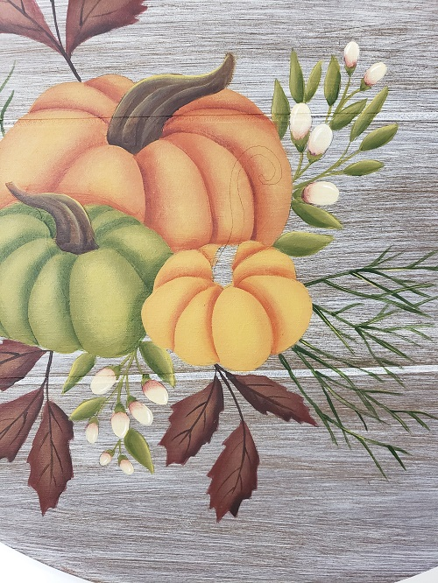

Use the Mezzaluna brush to dry brush a highlight onto the center of the sections with Antique Gold. Using the dirty brush, add an extra highlight on all of the pumpkins on the tops of each section with Light Buttermilk. Add the stem the same way as the other pumpkins.
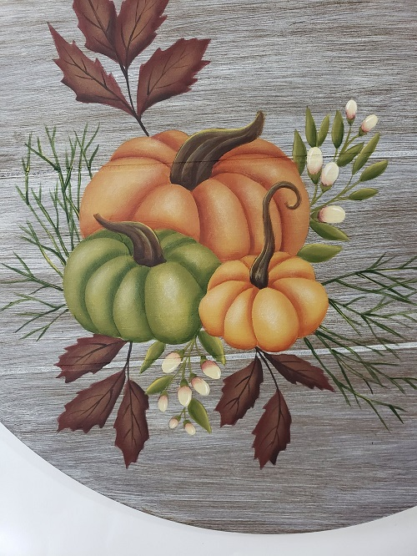

Lettering:
Lay the stencil on the upper right side of the plaque. Load the dry Stencil-Pro brush with Antique Maroon and wipe some of the paint onto a paper towel. Using a circular motion, rub the color over the stencil.
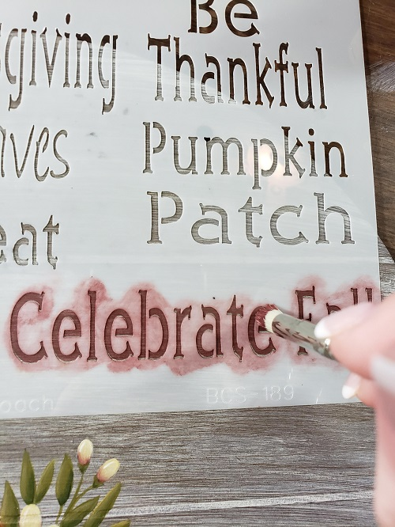

Wipe most of the paint onto a paper towel a reload the brush with Light Buttermilk. Wipe some of the paint onto a paper towel. Shift the stencil up and to the right slightly and rub this color onto the stencil. This will give the effect of a shadow under the letters.
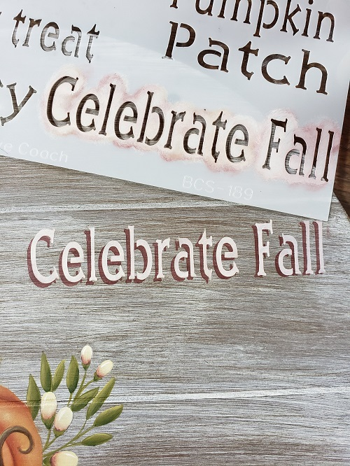

If desired, use the liner brush to connect the space in the letters with Light Buttermilk.
Outside Edge:
Load the #10 Shader with Antique Maroon. Add the checks on the outside edge of the plaque by pulling laying the brush flat against the surface and pulling out to the edge in one stroke. Use the stylus to add Splendid Gold dots between the checks.
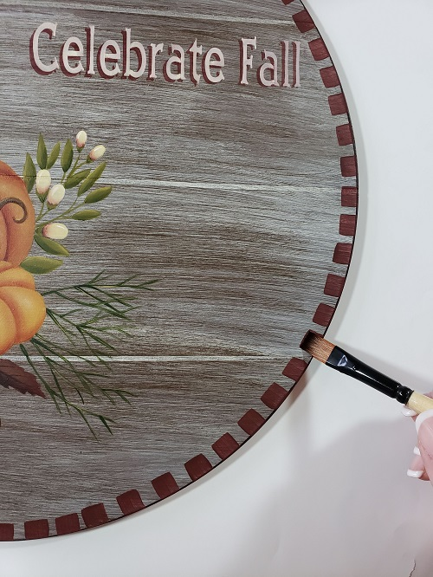

To create the circle, take a 10” round template (I used a bowl from my kitchen!) and using the Gold Leaf Pen, trace around the circle leaving a break in the circle by the lettering and the leaves.
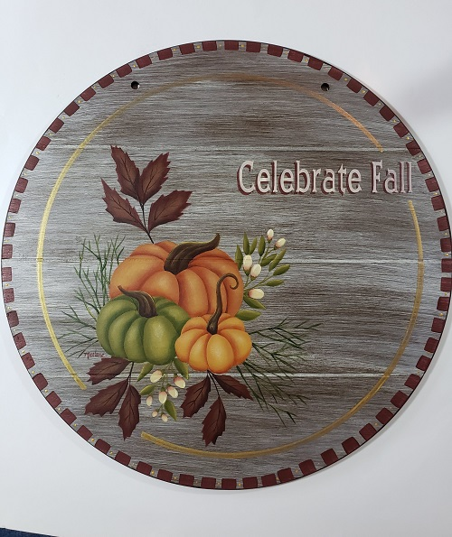

If you don’t have the gold pen, you can trace the circle and paint it in with Splendid Gold. Let dry well.
Finishing:
Remove any remaining transfer lines. Paint the sides and back with Soft Black. Let dry well. Varnish with 2-3 coats of DuraClear Varnish. When dry, add the ribbon to the plaque.

