Joy to Christmas

By Elisabetta De Maria

Dearest painting friends, Joy to Christmas is born from the love for Christmas, from the love for these fantastic colors, from the desire to offer to those who love me always something special, something made ... with love ... With Decoart colors all this. ...it can be done! Happy Painting my dear friends!

Supplies
Surface :
The wood surface measures 29 x 33 cm.

Paints Decoart Americana Acrylics
- Antique Maroon
- Blue Chiffon
- Black Plum
- Bright Blue
- Burnt Orange
- Burnt Sienna
- Burnt Umber
- Camel
- Country Red
- Fiery Red
- Flesh Tone
- Grey Sky
- Hi-Lite Flesh
- Honey Brown
- Jack-O’-Lantern Orange
- Lamp Black
- Milk Chocolate
- Neutral Grey
- Plum
- Primary Blue
- Sand
- Dried Clay
- Soft Black
- Titanium White
- Williamsburg Blue
- Winter Blue

Mediums :
- Gesso Decoart
- Light Satin Varnish Decoart

Brushes :
- Filber Brush Black Gold n 2
- Liner Brush Black Gold n 5/0
- Pointed Flat 2/0 Micron Dynasty Brush
- Flat Brush Black Gold 4,6, 5/8 Dynasty Brush
- Angular Brush for Floating Black Gold 1/2, 3/8 , 1/4 , 1/8 Dynasty Brush
- Mop Brush to Blend and Soften Color 3/8 Dynasty Brush 400

Project Supplies :
- Ball Stylus
- Fine Sandpaper
- Lint Free Cloth
- Paper Towel
- Wet Palette
- Water Containers
- Tracing Paper
- Graphite paper to transfer the design
- Paper Palette
- Dazzling Metallics Glorious Gold,
- Christmas Stamps

Painting Techniques
Basecoat: Opaque application of background color on surface or component.
Shading and Highlighting: Load a small amount of paint in the corner of an Angle Brush, stroke the brush back and forth on the palette paper until most of the paint is out of the brush. It is important that the color be worked in the brush until it is completely transparent. Apply as if walking out a float of color. Repeat if necessary and use the Mop brush to blend the color.
Drybrush: I use brushes that are dome shaped, rounded and have shorter hairs. Dip the brush into the paint and then wipe the brush on a dry paper towel , rotating the brush until only a residue of paint remains. Move to the surface, use a light pressure and begin “scrubbing” the paint out of the brush, slowly, in a small circular motion. Work the paint outward, allowing it to diminish so that there is a gradation of color.
Instructions
Use the brushes you are most comfortable with apply a coat of Gesso Decoart and let it dry.
Sanding with fine sandpaper and dust with a soft cloth.
Place the pattern on the surface and transfer the main lines with graphite paper leaving out details until later.
SHADING AND HIGHLIGHTING: ( Refer to color photo for placement)
Background
Basecoat: Blue Chiffon
Paint the background with Blue Chiffon trying not to cover the part that will have to see the birth of Santa Claus.
Start painting all the basecoat of all the parts.
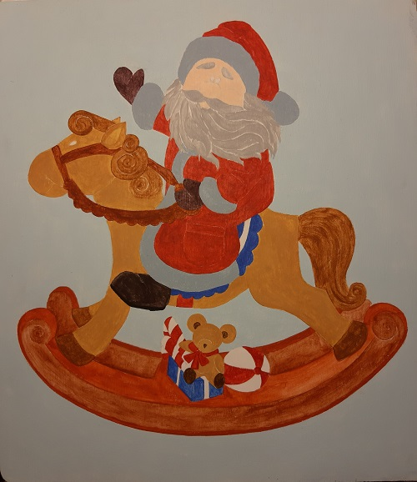
Santa Claus
Face
Basecoat: Hi - Lite Flesh.
Shade with Flesh Tone and deepen with Dried Clay.
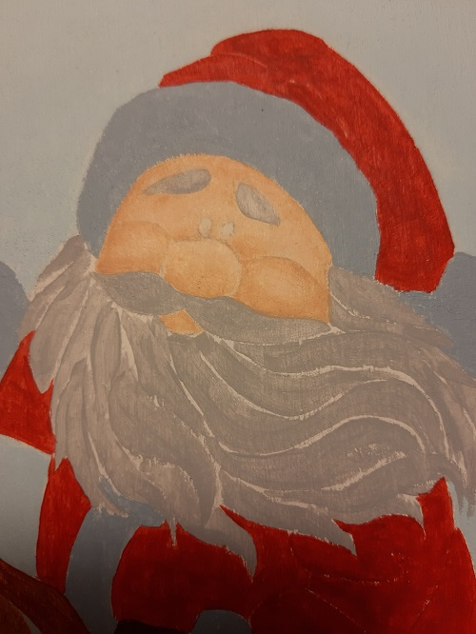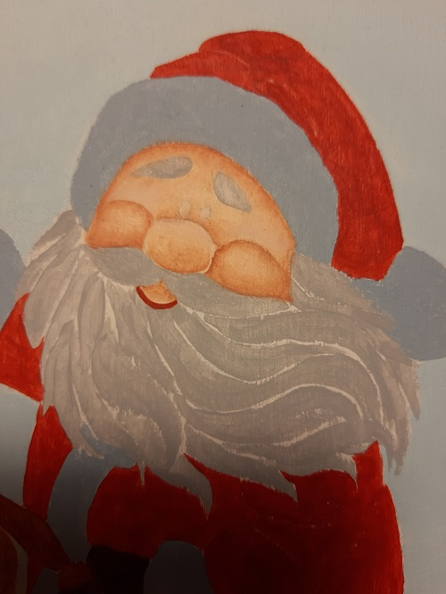
Highlight with Titanium White.
Paint the eyes with Lamp Black and the light spot with Titanium White.
Paint the cheeks with the technique of floating with Country Red.
Create the mouth line with the same color.
Paint the eyebrows, mustaches, beard and hair with a round brush and the color Grey Sky giving them their shape.
Wipe over with the same brushstrokes with the Titanium White color.
At the end shade with Neutral Gray and go over again with Titanium White, also using a liner brush to create the thinnest hair on the eyebrows
Jacket and Hat
Basecoat: Country Red.
Shade with Black Plum and highlight with Hot Fiery Red
At the end create the ornamental lines with a liner brush and Dazzling Metallics Glorious Gold (Step 13, 14).
Pom Pom and Band Hat and Jacket
Basecoat: Winter Blue.
Shade with Williamsburg Blue and highlight with Titanium White
At the end of all the work, create softness with strokes in various directions using the liner and Titanium White.
Gloves
Basecoat: Black Plum.
Shade with Soft Black and highlight with Plum.
Shoes
Basecoat: Soft Black.
Paint the sole and heel with Lamp Black.
Shade with Lamp Black and highlight with Grey Sky (Step 7).
At the end paint the laces with Dazzling Metallics Glorious Gold.
Toys
Baby Bear
Basecoat: Honey Brown + Camel (1: 1).
Shade with Milk Chocolate and deepen with Burnt Umber.
Highlight with Camel.
Paint the Muzzle with Camel.
Highlight with Sand
Inner Ears, Eyebrows, Nose, Line and Foot Palm
Basecoat: Burnt Umber
Eye
Basecoat: Lamp Black
Create the light spot with Brush liner and Titanium White.
Bow
Basecoat: Country Red
Shade with Black Plum and highlight with Fiery Red.
At the end give a light to the center with Dazzling Metallics Glorious Gold.
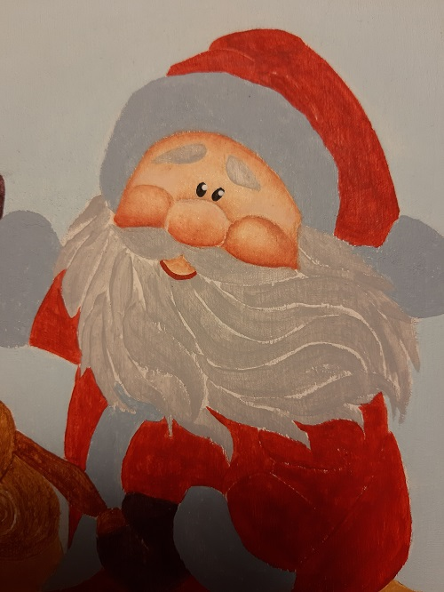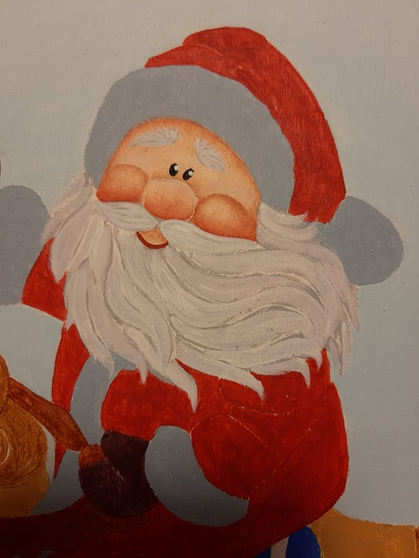
Ball
Basecoat: Country Red and Titanium White
Shade the red part with Black Plum and highlight it with Fiery Red.
Shade the white part with Grey Sky.
Candies
Basecoat: Country Red and Titanium White
Shade the red part with Black Plum and highlight it with Fiery Red.
Shade the white part with Honey Brown.
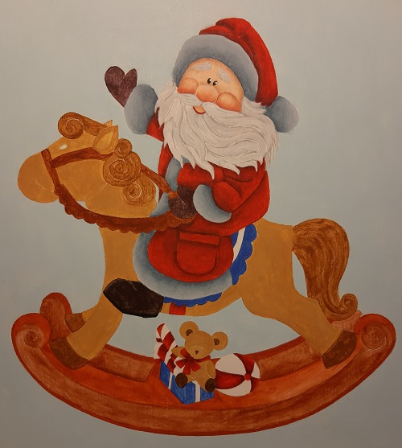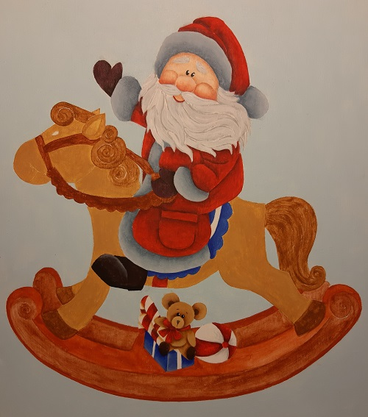
Gift box
Basecoat: Bright Blue, Dazzling Metallics Glorious Gold.
Shade the blue part with Primary Blue and highlight with Grey Sky .
At the end paint the ribbon with Dazzling Metallics Glorious Gold and reinforce shading under toys with Soft Black .
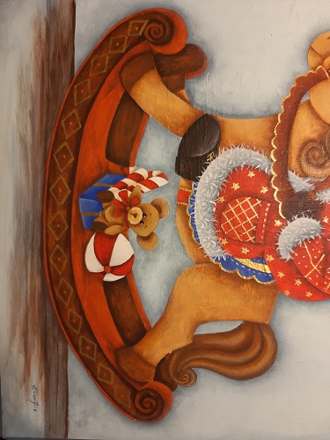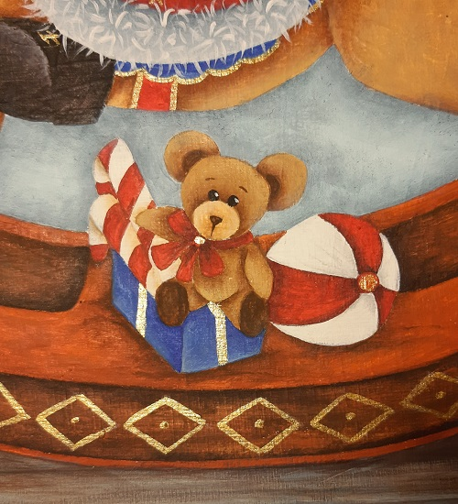
Rocking Horse
Head and Body
Basecoat: Honey Brown + Camel (1: 1).
Shade with Milk Chocolate and deepen with Burnt Umber.
Highlight with Camel .
At the end add a slight shade with Burnt Orange.
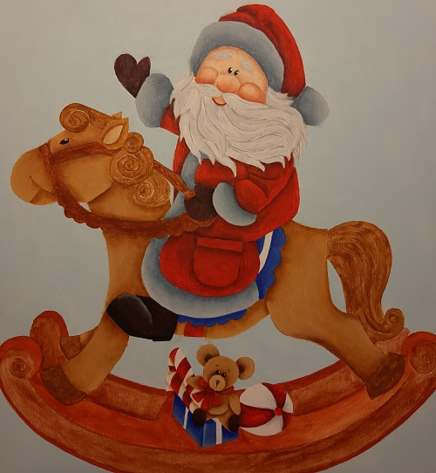
Ears External Basecoat: Honey Brown
Internal Basecoat: Camel
Shade the outside with Milk Chocolate and deepen with Burnt Umber.
Highlight the inside with Sand and shade with Honey Brown.
Eye
Basecoat: Lamp Black
Create the light spot with Brush liner and Titanium White.
Nostrils and Mouth
Basecoat: Burnt Umber
Shade the mouth with Burnt Umber.
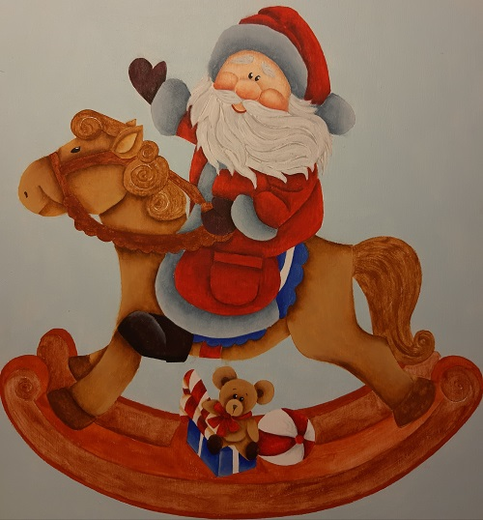
Tail, Clogs and Mane
Basecoat: Milk Chocolate.
Shade the curls of the tail and mane with Burnt Umber
Shade all with Burnt Umber and highlight with Camel.
At the end add light strokes with Burnt Orange.
Bridles
Basecoat: Burnt Sienna
Shade with Antique Maroon and highlight with Burnt Orange.
Reinforce the highlight with Jack-O’-Lantern Orange.
At the end paint the details with Dazzling Metallics Glorious Gold.
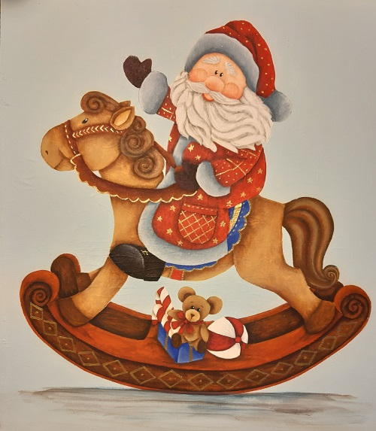
Saddle
Basecoat: Bright Blue, Dazzling Metallics Glorious Gold and Country Red.
Shade the blue part with Primary Blue.
Shade the red part with Black Plum and highlight it with Fiery Red .
At the end outline with Dazzling Metallics Glorious Gold.
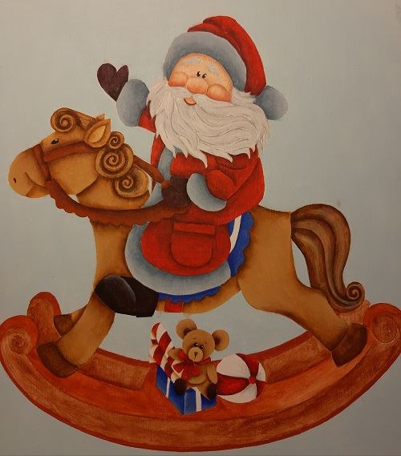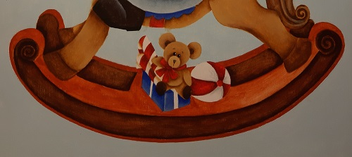

Rocking
Paint the side part first with Burnt Sienna and then lightly rub back with Burnt Umber.
Shade with Soft Black and highlight with Bunrt Orange and give light strokes with Orange Jack-O’-Lantern .
Paint the top with Burnt Orange.
Shade with Burnt Umber and highlight with Jack-O’-Lantern Orange.
Draw the rhombus design with a liner brush and Dazzling Metallics Glorious Gold and add all details in the work.

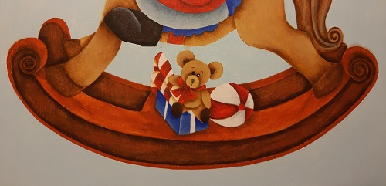
Ground
Work with a corner brush with the following colors: Soft Black, Burnt Umber, Burnt Orange and Williamsburg Blue.
Finishing
Shade all the work with Williamsburg Blue.
Use Christmas stamps as you like using Williamsburg Blue + Winter Blue (1: 1).
Paint the details with Dazzling Metallics Glorious Gold

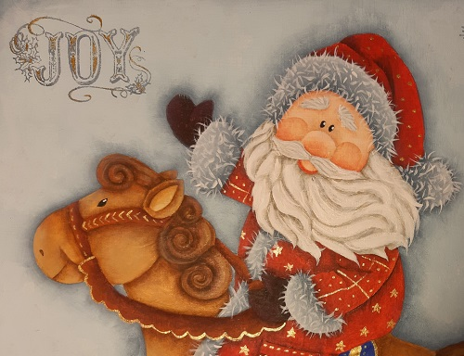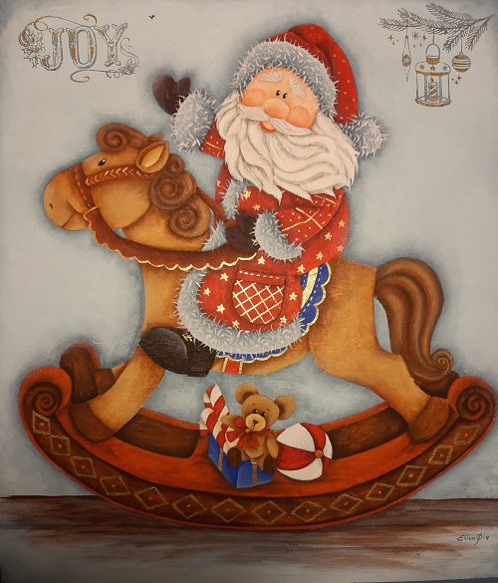
Varnish as desired.

I hope you Enjoy Painting this as much as I did!

Happy Painting Elisabetta

