Blooming Americana Color Wheel

Designed by : Debra Mills

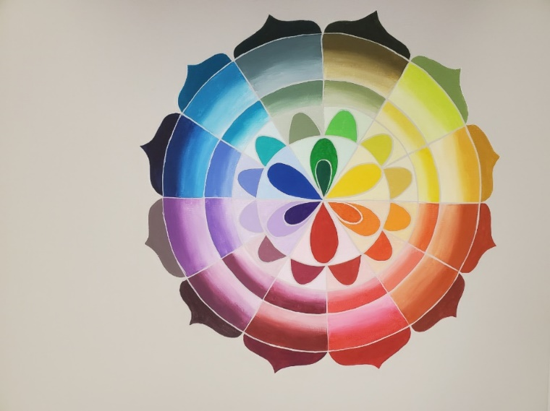

Americana Colors Used:
DA364-6 Aloe
DA147-1 Antique Green
DA370-3 Berry Cobble
DA172-1 Black Plum
DA283-1 Blue Harbor
DA228-1 Bright Orange
DA329-1 Bright Salmon
DA352-3 Brilliant Purple
DA016-1 Burnt Orange
DA014-1 Cadmium Orange
DA010-1 Cadmium Yellow
DA020-1 Calico Red
DA238-1 Canyon Orange
DA208-1 Celery Green
DA330-1 Chartreuse Yellow
DA235-1 Citron Green
DA018-1 Country Red
DA112-1 Cranberry Wine
DA128-1 Deep Burgundy
DA331-1 Desert Cactus
DA044-1 Desert Turquoise
DA101-1 Dioxazine Purple
DA230-1 Festive Green
DA335-1 Frosted Plum

DA017-1 Georgia Clay
DA168-1 Golden Straw
DA371-3 Golden Yellow
DA133-1 Hauser Dark Green
DA131-1 Hauser Light Green
DA219-1 Heritage Brick
DA048-1 Holly Green
DA034-1 Lavender
DA194-1 Marigold
DA373-3 Mermaid Tail
DA294-1 Mulberry
DA326-1 Peacock Teal
DA366-3 Periwinkle
DA293-1 Persimmon
DA113-1 Plantation Pine
DA175-3 Plum
DA360-3 Plum Suede
DA199-1 Primary Red
DA138-1 Prussian Blue
DA272-1 Purple Cow
DA378-3 Purple Petal
DA140-3 Red Violet
DA377-3 Royal Navy
DA361-3 Sand Gray
DA01-1 Snow (Titanium) White
DA275-1 Sour Apple
DA363-3 Summer Squash
DA012-1 Tangerine
DA332-1 Teal Mint
DA357-3 Thicket
DA036-1 True Blue
DA143-1 True Ochre
DA265-1 Tuscan Red
DA386-3 Warm Sunset
DA324-3 Watermelon Slice

BRUSHES:
#8, #4 flat shader
#4, #6 round
#1 script liner
¾” flat wash

SURFACE: 16x24 stretched canvas

MISCLLANEOUS SUPPLIES: gray graphite paper, stylus, tracing paper, water container, palette

STEP ONE
TRANSFER PATTERN

- Trace and transfer pattern onto canvas. Omit the color names.

- 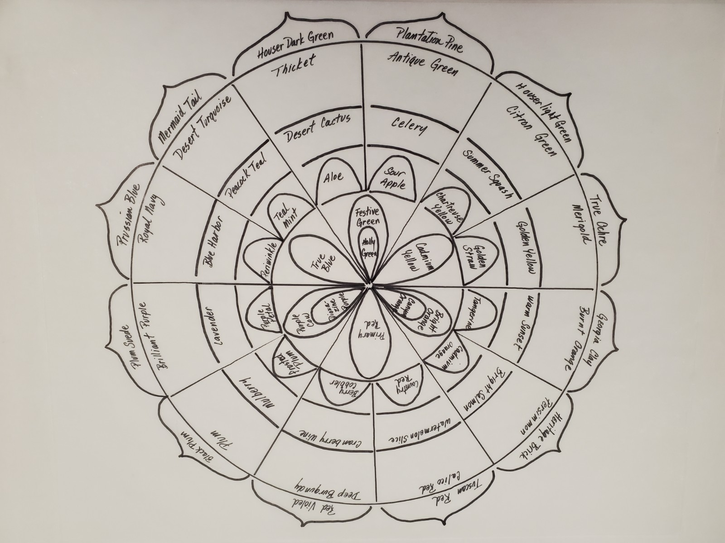
Example # 1

STEP TWO
Painting color slices

- Following the diagram, paint each color on the outside of the color wheel solid as in Example #2.
- Paint the petal shapes at the center of the color wheel solid using the labeled color.
- Paint the half petal shape solid using the labeled color. Paint the background in each of these sections with a mix of Titanium White and a very small amount of the solid color.

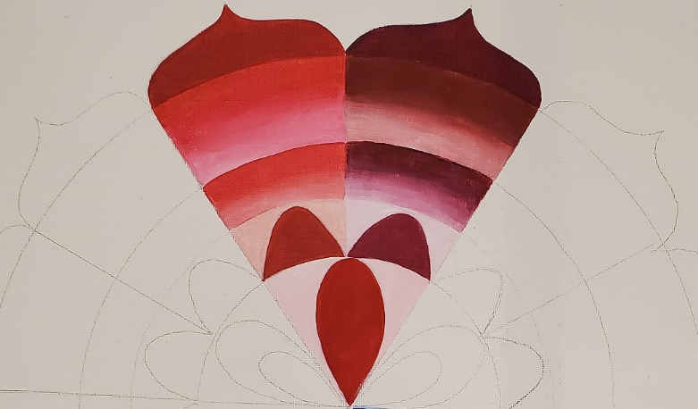
Example #2

STEP THREE
- Paint a narrow portion of the first section of the color slice with the labeled color. Then add a small amount of Titanium White into the color and continue filling in the slice. Continue adding more Titanium White to the mixture and blending as you continue to fill in the section
- Do this with each color in the first section of the color wheel.
- Paint the second section of the slice in the same manner using the labeled colors Adding Titanium White to the colors as you did with the first section
- Continue in this manner with all the section slices until they are filled in.

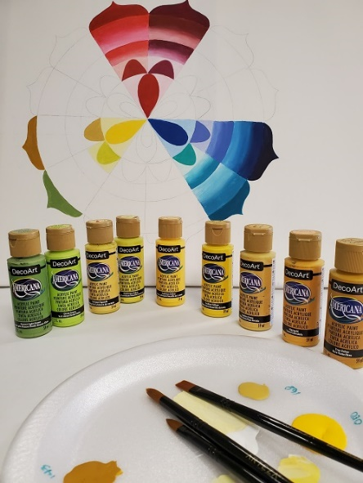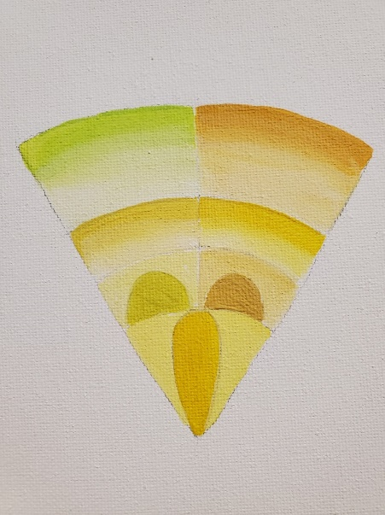

STEP FOUR

- Continue painting each section of each slice in the same manner using the labeled color around the color wheel.

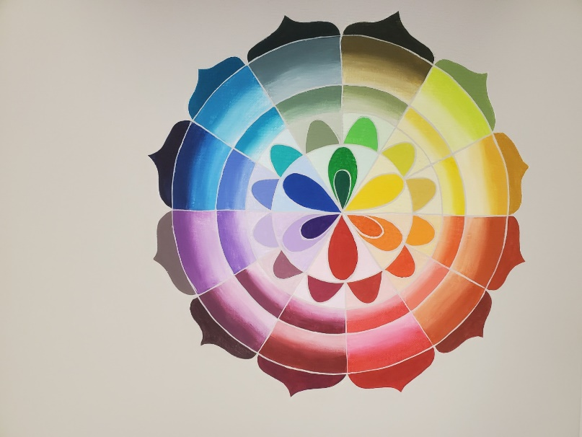

STEP FIVE
- Using a script liner brush with Sand Gray thinned with water and paint between all sections of each slice.
- Paint background with Sand Gray.

