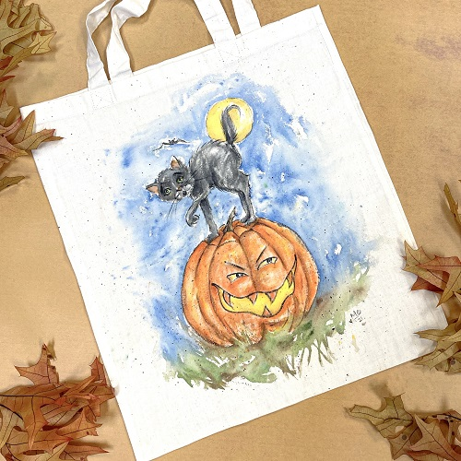

Scaredy Cat and Pumpkin – Tote Bag

By Amy Boettcher
Paints: DecoArt So Soft Fabric Paints

DSS23- Dark Chocolate
Dss24- Lamp Black
Dss36- Ultra White
Dss42- Primary Blue
Dss25- Christmas Red
Dss47- Hauser Light Green
Dss98- Olive Green
Dss37- Primary Yellow
Dss4- Cadmium Orange
Dss93- Bittersweet Orange
Dss76- Tangerine
Dss52- Fuchsia
Dsf1- Transparent Fabric Medium

Brushes:
#2 Liner
#8 Flat
#12 Flat

General Supplies:
Tote Bag approx. 14 x 16” from Hobby Lobby
Hair Dryer
Chalk pencil
Graphite pencil
Tracing paper
Cardboard to fit in tote bag so paint doesn’t bleed through
Waxed paper or palette paper to go over cardboard
Water container
Paper towels
Palette paper
Old toothbrush (optional)

Prepare to paint:
Cover front of cardboard insert with waxed paper to keep paint from bleeding through.
Copy the pattern on to tracing paper.
Chalk the back of pattern lines and trace lines to transfer chalk onto fabric.
Tape pattern on tote bag and retrace lines with back of paintbrush handle. Check to see that all details transferred before you remove the pattern.

Trace ONLY the lines necessary to obtain the general shape. The fewer lines the better so you don’t have to erase too much chalk from fabric. When line work is painted and dry just dust or rub off excess chalk to erase lines.

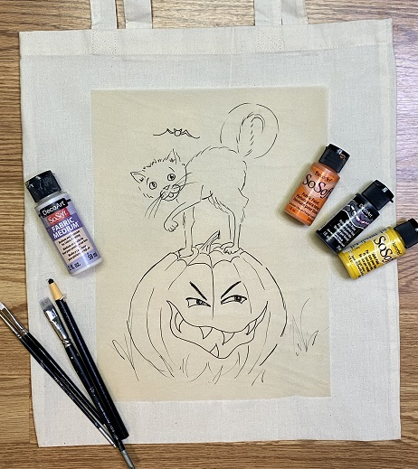
Painting Tips:
This painting is meant to be playful and relaxed. Don’t worry too much about following lines exactly.

This is a watercolor technique so don’t be afraid of color running outside the lines just a bit, but remember in this style the color will keep “crawling” for up to an hour. Do not get too carried away with the water. To stop the color from bleeding, use a hot hair dryer.

The Transparent Fabric medium will slow the paint from crawling, so for areas you want to keep contained, use more medium instead of water, about 2 parts paint to 1-part Transparent Fabric Medium.

General Painting Instructions:
Outline -
Because this is a whimsical design, loosely outline all details in BLACK. Dip brush in clear water before starting. Wipe off drips from handle and ferrule of paintbrush. I use about 2 parts paint to 1-part Fabric Medium to keep paint flowing but not runny. If desired, you can add a small amount of water to make paint flow more smoothly.
You are not painting with a coloring book approach. Allow some areas to be darker than others; let some parts
of the white background enhance the highlighted areas. Have fun with it!

Cat & Bat -
Thin the Lamp Black paint with Transparent Fabric Medium and wash over the cat and bat to look grayish. Feel free to leave spontaneous white spots as highlights. Sideload a flat brush with Transparent Fabric Medium and Lamp Black to float shadows in darker areas. Paint inside of cat ears and nose with just a touch of Fuchsia. Eyes are a touch of light green, highlight white.
Eyes & Ears
Moon -
Wash with Primary Yellow leaving some areas unpainted to create white highlights.
On your dirty, yellow brush, add a touch of Chocolate Brown to float shade and add warmth around some edges.

Jack-o-lantern –
Wash a light coat of Primary Yellow inside mouth, eyes (leaving highlights in pupils) and on pumpkin, leaving natural, unpainted highlights here and there. Shade inside mouth first with a bit of Bittersweet and then Chocolate Brown around edges. Paint each pumpkin section and teeth with a wash of Tangerine, then Cadmium Orange. Use Bittersweet and Chocolate Brown to shade sections. The Stem is just a wash of Chocolate Brown.

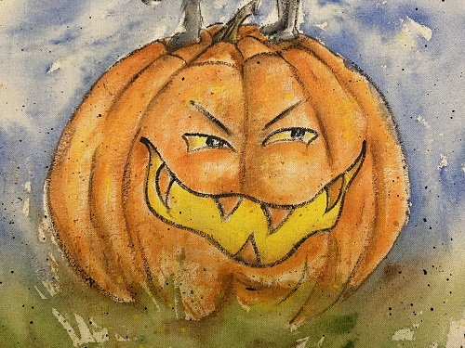
Face Details

NOTE:
I leave the bottom of pumpkin unfinished and dampened to bleed into what will be the grass. Shade the bottom of pumpkin and under the cat’s feet with a little extra Chocolate Brown to add depth and shadows.

Grass & Ground –
Wet the entire area slightly with clear water. You do not need to use Transparent Fabric Medium unless you want to. Thin down the Olive-Green paint with water and quickly pull up some grass strokes, leaving some areas empty.

Touch a few spots with Chocolate Brown and let it bleed into grass. Allow grass to bleed up into the pumpkin to give the appearance that the pumpkin is sitting down in the grass. Cover the face of the pumpkin and sky with a paper towel and speckle the grass Olive Green, Chocolate Brown and Black.

How to speckle:
It’s always a good idea to practice on a scrap surface before moving to your tote bag. Working one color at a time, thin paint with a bit of clean water. Fill your liner brush with the thinned paint. Tapping the handle of the liner brush against the handle of another brush will create speckles and spatters across the surface. If you prefer, you can use an old toothbrush loaded with thinned paint.

While still wet, start on sky.

Sky –
Wet background with clear water, leaving a few dry spots for clouds. Let water seep all the way in the grass. Add Transparent Fabric Medium around areas and items (like the moon, cat and pumpkin) you want to prevent the water from affecting.

I mix just a touch of Lamp Black into the Primary Blue to darken the sky color to a deep navy color. Just drop very wet color around sky, being more careful to use Transparent Fabric Medium as a barrier where you don’t want the color to run. Don’t get too carried away with the water because it will continue to bleed and creep for a while. If necessary, firmly blot excess moisture and color with a paper towel.

While the painting is still wet, Speckle freely. Cover areas you want to keep clean, like the eyes, with a bit of paper towel. I speckled green, brown, and black in the grass and on pumpkin. I speckled the sky with the Primary Blue mixed with a touch of Black.

Let dry completely. Heat set with hairdryer or with iron on medium ironing on the BACK. Never put hot iron directly on paint.

ENJOY!!!!

