Falling Leaves
By Brenda Stewart
Copyright 2021

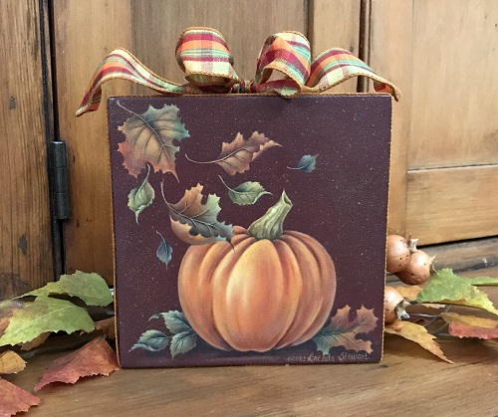

The vivid hues of Autumn speak to me like no other, and I love painting and decoration for that season. Let yourself go and have fun exploring the many color options give for this painting. Remember there are no exacts because nature paints the falling leaves with endless variety.

DecoArt Americana Acrylics
﻿DA364 Aloe
DA147 Antique Green
DA160 Antique Maroon
DA157 Black Green
DA015 Cadmium Red
DA238 Canyon Orange
DA010 Cadmium Yellow
DA128 Deep Burgundy
DA163 Honey Brown
DA164 Light Buttermilk
DA194 Marigold
DA223 Traditional Burnt Sienna
DA 221 Traditional Burnt Umber

﻿MEDIUMS
DecoArt Traditions Extender and Blending Medium (optional)
DS60-9 Americana DuraClear Matte Varnish

Supplies
6” X 6” X 2” wood panel available at www.brendastewart.com
Wood sealer
Fine sandpaper, Tack cloth
Brush basin
Palette knife
Sta-Wet Acrylic palette or palette of your choice.
High density foam roller
.05 Red Frixion pen
White transfer paper
Easy release painter’s tape

Brushes
- Angular Brushes: 1/8”, 1⁄4”, 3/8”, 1⁄2”, 5⁄8”
The angular brushes may be used for much of the base coating in the painting, and for the side
loaded application of paint throughout the painting.
- ﻿Bristle Scrubber: Stiff, white bristle scrubber, similar to a short filbert. #0, #2
These are used for correcting and/or softening color.
- Mini Mops: #2, #4, #6, #10
The mops are used for softening color and for dry brushing.
- ﻿Soft Moon Mop: 1/8”, 1⁄4”
These brushes are used for softening of color and for applying color in some areas.
- Kolinsky Sable Liner: #2 or #4
This brush is used for small detail and line work.
- ﻿Small Bristle Fan Brush
The small fan brush is used for spattering.
Preparation
﻿1. Sand all surfaces and wipe with a tack cloth.
2. Apply a penetrating wood sealer. Allow to dry as directed.
3. Sand lightly and wipe with a tack cloth.
4. Basecoat the entire panel with a mix of Antique Maroon + Deep Burgundy (2:1). Use a high
density foam roller to basecoat all flat surfaces. Apply two coats.
Note: You may wish to basecoat only the top painting surface at this time. The dark red scratches easily. If the basecoat is applied to the sides and back surfaces before doing the painting, apply one coat of the finish varnish to protect the surfaces.
5. Make a tracing of the pattern on tracing paper with a fine point pen. Position the pattern on the panel and tape in place. Use a stylus and white transfer paper to transfer the pattern to the tray. Transfer only the outline and stem on the pumpkin. Do not transfer the inner and sectional lines at this time or any inner lines on the leaves. The inner lines are applied after base coating the objects in their basic colors.

Mixtures
﻿1. Antique Maroon + Deep Burgundy (2:1)
Painting
• Always use as large a brush in an area as you can comfortably handle.
• Dampening the surface with water before applying a step gives time to walk out the side load or soften the paint application with a mop. Dampening is usually not needed in small areas.
• Move to other areas to work while waiting for drying time between steps.
• Dry brushing is used for some application. This may be true dry brushing, or you may use a modified dry brushing technique. For modified dry brushing, dampen the surface very slightly before applying the color with a scantly loaded and blotted mop brush.
• Apply details and line work on a dry surface. Use a liner brush or very fine point round. Thin the paint with water for liner brush applications.

INSTRUCTIONS

Step 1: Basecoat (Refer to Step 1 photograph)
Basecoating should be done with as large a brush as you can comfortably handle within a given area. Thin the paint with just enough water to obtain a good flowing consistency. Load the paint into the brush thoroughly. There should be no ridges or lumps of paint visible on the brush. Apply as many coats as needed for good coverage. Allow for thorough drying between applications. Some areas are based with a side loaded application of color. When basecoating with side loaded color, always dampen the surface slightly to allow time to move the color out from the applied area.

Pumpkin
Basecoat: Basecoat the pumpkin solidly with two coats of Canyon Orange + Honey Brown + a little Light Buttermilk. The Light Buttermilk will help the basecoat cover more quickly. Then apply 1-2 coats of Canyon Orange + Honey Brown. The color will appear a bit dull (on the palette) until you apply it to the dark red background. Check your color against the Stage 1 photograph.

Pumpkin Stem: Basecoat the pumpkin stem with a solid basecoat of Light Buttermilk + Raw Sienna + a touch of Antique Green. Apply 2 coats for good coverage.

﻿ 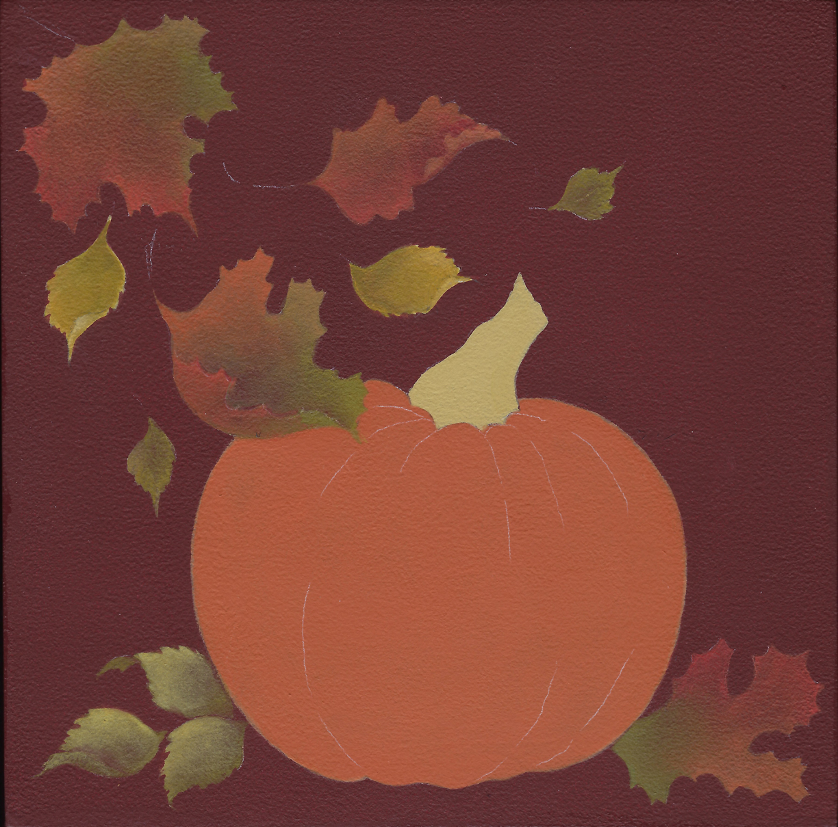
Step 1

Leaves: Use a side loaded brush to basecoat the leaves with various brush mixtures. Turn the color side of the brush toward the leaf edges and walk the color inward. Allow the colors to work together on the surface. Add some color to the interior of the leaves with a small round mini mop. Some of the leaves have serrated edges. It is easy to achieve these with the angular brush.

#1 Leaves: These leaves have a great variety of colors used in the basecoat. There really is no right or wrong. Refer to the Stage 1 color photograph for color reference but remember, there are no exacts. Use as many of the following brush mixtures as you wish to give color variety to the leaves.
Canyon Orange + Honey Brown
Canyon Orange + Raw Sienna
Canyon Orange + Cadmium Red
Canyon Orange + Traditional Burnt Sienna
Canyon Orange
Cadmium Red
Cadmium Red + Traditional Burnt Sienna
Antique Green + Honey Brown
Antique Green + Raw Sienna
#2 Leaves: Side load the 1⁄4” angular brush with Antique Green + Raw Sienna + Marigold + a touch of Light Buttermilk. Undercoat the #2 leaves. When dry, wash over with Marigold + a touch of Antique Green. Then add some Antique Green + Raw Sienna. Reinforce the lighter basecoat value (if needed) with Marigold + a touch of Antique Green.

#3 Leaves: These leaves are also basecoated with the 1⁄4” angular brush. The two smaller ones that are falling are less predominate than the three to the left side of the pumpkin. They only receive the first basecoat value.
Antique Green + Raw Sienna
Antique Green + Raw Sienna + a touch of Marigold

When the basecoating is complete and the objects are dry, apply inner pattern lines as needed

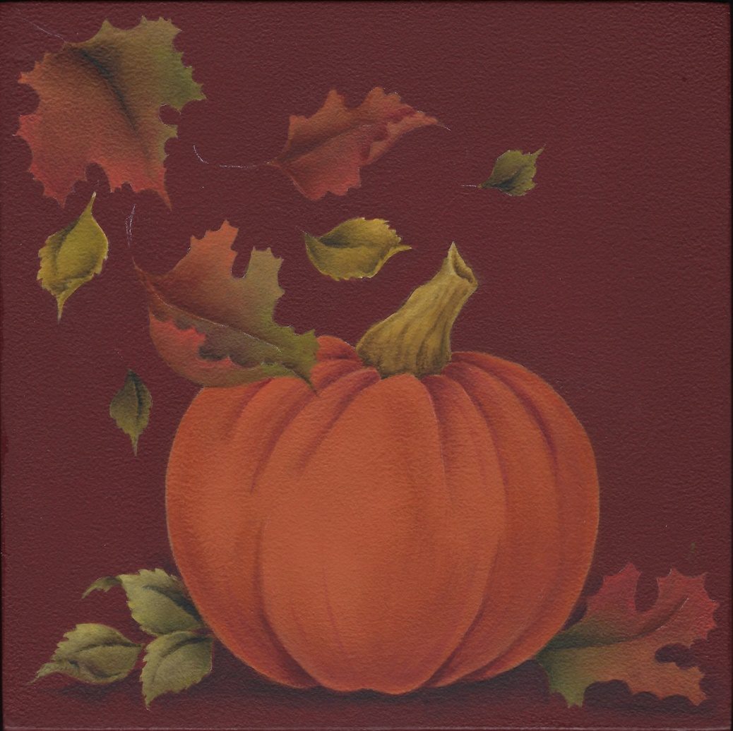
Step 2

Step 2: Shading (Refer to Step 2 photograph)
Much of the shading is applied with side loaded angular brushes. Use an appropriate size brush for the area being shaded. Blend the side load on the palette until the paint is graded in value. If the size of the area warrants it, dampen the area prior to applying the shading. This will provide a little extra time to apply the shading and to walk the color out into the area until it blends into the underlying color(s). The blending edges of the shading may also be softened/blended with a mop. Repeat the shading steps as many times as necessary to build the correct values or to walk the color far enough out on the object. Allow for thorough drying between applications. Each deeper value occupies a smaller area within the previously applied value. Occasionally shading is applied with a round brush. This is normally applied on a damp surface and blended with a mop.

Pumpkin
Shade: Apply a pale value side loaded shading of Traditional Burnt Sienna + a touch of Traditional Burnt Umber to a crescent shaped shading that starts approximately halfway up the left side of the pumpkin, continues around the bottom and stops about three quarters of the way up the right side. The first value of this shading is pale and goes all the way to the edge of the pumpkin. Allow this to dry. Repeat with a stronger value of the same brush mixture that is slightly off the edge of the pumpkin. Next, add a side load of Mix #1 on the inner blending edge of the crescent. Allow this to dry.
Next, use a medium size angular brush side loaded with Traditional Burnt Sienna + a touch of Traditional Burnt Umber and define the sections of the pumpkin. Repeat as needed, and then add Mix #1 as the darkest value shading. Side load a smaller angular brush with the same color and shade around the pumpkin stem. The darkest areas are at the lower edge of the pumpkin between sections and around the stem.

Streaks: Pull some shading streaks out from the bottom of the pumpkin and also from the dark area around the pumpkin stem. Use the round brush loaded in the Mix #1.

Add dry brushed shading: Add more shading and scruffing on the pumpkin skin with a round mini mop and dry brushing. Load the mop with a scant load of Traditional Burnt Sienna + Traditional Burnt Umber.

Stem
Shade: Side load a 1⁄4” angular brush with Antique Green + Raw Sienna and apply the first medium shading value to the stem. When dry, darken a smaller area within the first shading with a side load of Antique Green + a touch of Black Green. Then add the darkest value with Burnt Umber + a touch of Black Green. Some gnarly dark streaks are added with a round brush.

Leaves
Some of the leaf areas are small, so apply just one or two shadings on a leaf at a time. Move from leaf to leaf, returning once a step is dry to add a different shading area or to walk the color out farther.
#1 Leaves: Use various brush mixtures for the shading, depending on the underlying colors.
Antique Green + a touch of Black Green
Traditional Burnt Umber
Traditional Burnt Umber + a touch of Black Green
Traditional Burnt Sienna + Traditional Burnt Umber
Mix #1 + Traditional Burnt Umber.

#2 Leaves: Antique Green + a touch of Black Green
Traditional Burnt Umber + Black Green

#3 Leaves: Black Green + a touch of Traditional Burnt Umber

Resting Shadows: Paint the resting shadows under the pumpkin and leaves with a side load of Mix #1 + a touch of Black Green. The shadows must establish a horizontal feeling. They are darkest right under the objects. Apply with side loaded color and then soften into the surrounding color with a mop brush. Pull some of the resting shadow color into the bottom pumpkin segment shadows. Then add a darker value to the resting shadows with Mix #1 + more Black Green.

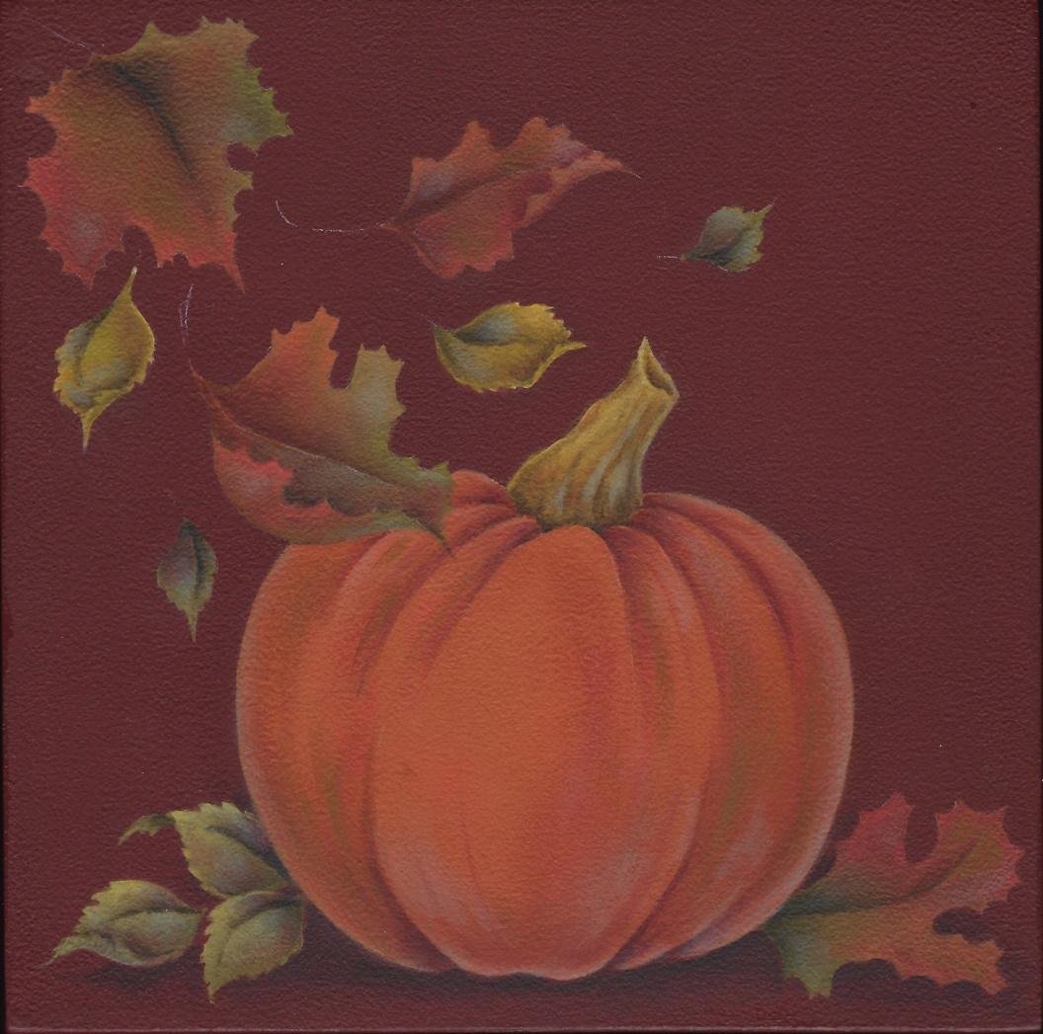
Step 3

Step 3: Accents (Refer to Step 3 photograph)
Accents are applied to objects to add interest or variety and to create color unity. They are often applied between values, resting in the areas that bridge between the dark and medium values. In the case of the leaves, they may be placed most anywhere and are used quite liberally. They may be applied with a side load of rather transparent color or may be dry brushed on the object. If too bold, soften them with a round mini mop or skim over them with a damp/dry.

Pumpkin:
Add dry brushes accents: Several colors are added as accents on the pumpkin:
Aloe is applied on the interior of the pumpkin and is also used on the receding and reflected light areas. It appears as a foggy greyish hue.
Cadmium Red is dry brushed on the pumpkin to add a warmer, redder hue.
Antique Green + Traditional Burnt Umber is dry brushed closer to the darker areas.

Stem:
Cool Accent: A round brush was used to apply Aloe accents to the stem. It was applied on a damp surface and blended a bit with a tiny mop. On the stem, it appears as a cooler, bluer hue.
Warm Accent: Apply dry brushed areas of Traditional Burnt Sienna.

All Leaves
Most of the accents on the leaves were applied with dry brushing. The 1/8” moon mop is excellent for the design if you are painting it the same size as the original. Following are the colors used on the original painting:
Cool blueish hue: Aloe
Warmer green: Antique Green + Traditional Burnt Umber
Cool red: Deep Burgundy
Warmer red: Deep Burgundy + Cadmium Red
Warmest red: Cadmium Red
You may also add any of the original basecoat colors if you feel they are needed to give good color balance.

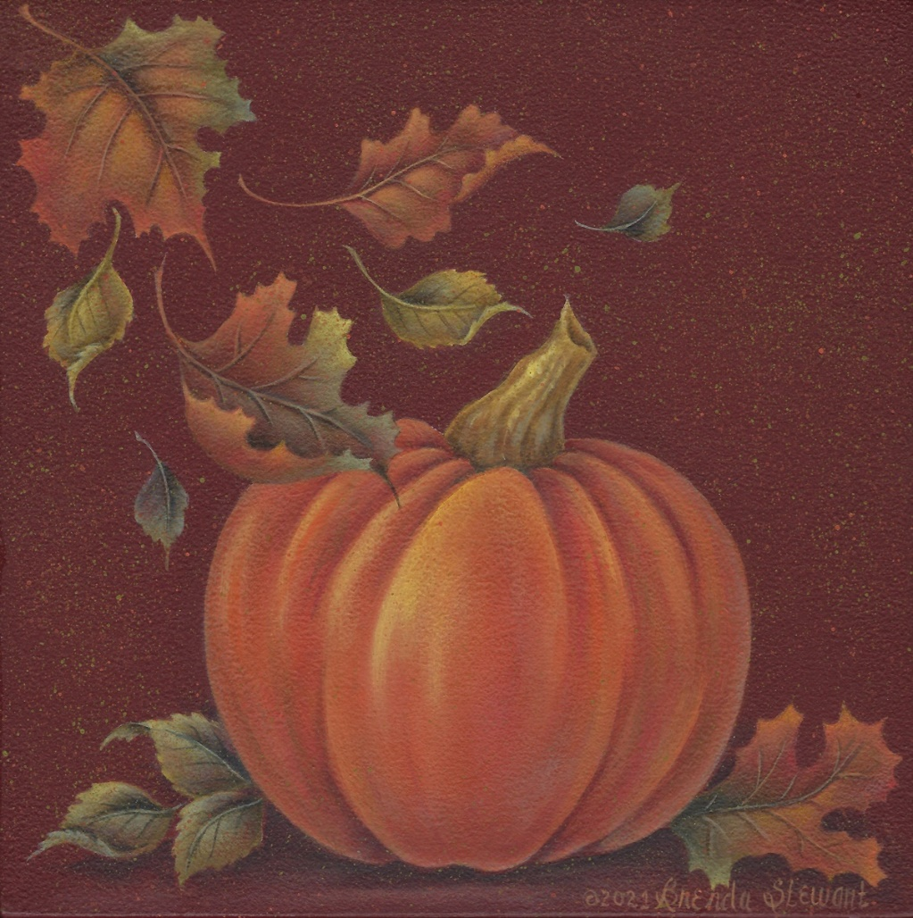
Step 4

Step 4 Highlighting and Details (Refer to Step 4 photograph)

Lights and highlights
Lights and highlights are built into the objects of a painting gradually. Each value will build within the previous value, occupying a smaller area. The highlights may be added in a variety of ways. On edges of the leaves, they are applied with a side loaded brush. They may also be applied with a round mini mop or moon mop brush and a very scant load of color. When applied with the mops, you may use dry brushing or modified dry brushing (done on a slightly damp surface.) In smaller areas, they may be applied on a damp surface with a round/liner brush. Blending of the highlights may be done with a round mini mop or the corner of a damp/dry angular brush.

Pumpkin
Build lights: Build lights on the pumpkin with a combination of modified dry brushing and true dry brush application of paint. Use the moon mops or round mini mops for the dry brushing.
Soft lights in darker areas of the pumpkin:
Canyon Orange + Honey Brown + Marigold
Canyon Orange
First light values in the lighter, brighter areas of the pumpkin:
Canyon Orange
Canyon Orange + Marigold.
Several values of Marigold
Highlights: Canyon Orange + Cadmium Yellow
Cadmium Yellow + Light Buttermilk
Gradually add Light Buttermilk to the brush mixture to lighten. Be sure that each lighter
value builds within the previous value.

Stem
Highlight: Apply the highlight values to the stem with the round/liner brush. The first highlight color is Marigold + a touch of Antique Green + a pin dot of Light Buttermilk. When dry, add a brighter value with Cadmium Yellow + a touch of Antique Green + a touch of Light Buttermilk.

Leaves
Highlight: Build highlights on the leaves with a combination of side loading and modified dry brushing. Side loaded color is used where highlights rest on an edge. Modified dry brushing is used for interior highlights. Determine the highlight values based on the underlying colors. Notice the highlights are stronger on the leaves that lead the eye to the pumpkin. They are rather subtle on the cool floating leaves, and the leaves to the right and left lower sides of the pumpkin.
Warm green areas: Antique Green + a touch of Marigold + a touch of Light Buttermilk
Antique Green + a touch of Cadmium Yellow + a touch of Light Buttermilk.
Cooler green areas: Aloe
Aloe + Canyon Orange (foggy greyish light used in transition areas between oranges/reds and greens)
Aloe + a touch of Cadmium Yellow + a pin dot of Light Buttermilk
Red areas: Canyon Orange + a touch of Cadmium Red
Canyon Orange
Lighter red or orange areas: Canyon Orange + Cadmium Yellow
Canyon Orange + a touch of Cadmium Yellow + a touch of Light Buttermilk
NOTE: Small amounts of Light Buttermilk may be added gradually to any of the highlight values to create lighter values.

Details
Vein: Very fine veins are added to the leaves with the round/liner brush. Use light and dark values from the leaf where they are being applied. Some leaves only have dark vein lines. If veins are too bold, glaze over them with a surrounding leaf color.

Leaf Stems: Continuation of color used for the vein of the leaf.

Add light streaks in the foreground: Apply soft streaked lights in the foreground with the moon mop.
Cadmium Red
Cadmium Red + Canyon Orange + a pin dot of Light Buttermilk.
Pull a mop over the streaks to soften them in place.

Spatter: Load a small bristle fan brush in soupy color. Hold it in a chisel position and rake a palette knife over the ends of the bristles. This will produce a fine spatter pattern. ﻿Some spattering may settle on objects. If it is more than you prefer, wipe off immediately with a damp brush.
Spatter the painting surface with:
Canyon Orange + Cadmium Red
Canyon Orange
Antique Green
NOTE: You may wish to apply one coat of the finish varnish over the design area prior to spattering.

Panel Sides: The sides of my panel were painted in the dark red basecoat. After finishing the painting, and applying the finish varnish, cover the sides with 1.5” fall ribbon. The ribbon used on the original contains many of the hues from the painting. Glue the ribbon in place with the seam at the bottom of the panel. Make a small bow to place at center top.
Alternately, you might wish to use some of the leaves from the design and sprinkle around the edges. If trimming with leaves, you could then spatter the sides with the same colors used on the design surface.

Varnishing the Painting
Apply approximately 8 to 12 coats of DecoArt Americana DuraClear Matte varnish on the painting. (Use only 2 coats on the panel sides if ribbon trim is to be used.) Stir the varnish with a clean spoon and a lifting motion. Apply thin, even coats, allowing it to dry between coats as directed on the product. Wipe the surface with a tack cloth before applying each coat. If, in spite of careful tacking, impurities occur in the varnish coats, you may gently wet sand after 3-4 coats of varnish. After the last coat of varnish, apply one coat of Americana Decor Creme Wax.

Brenda Stewart by Design
Email: Brenda@brendastewart.com
